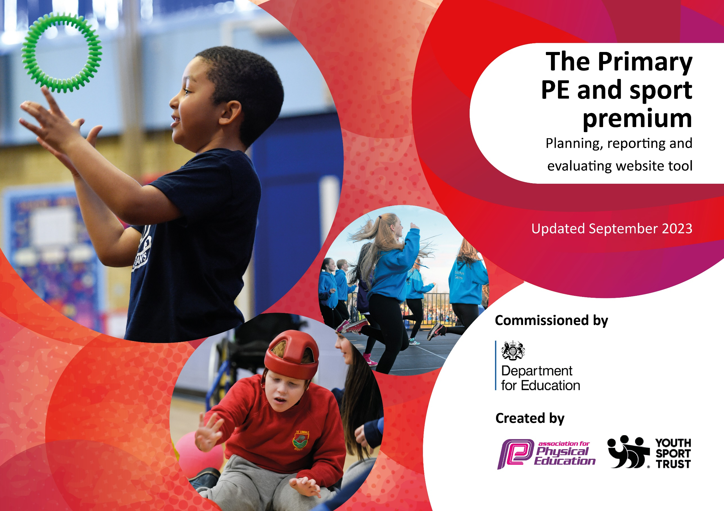

Jubilee Academy
2025-2026

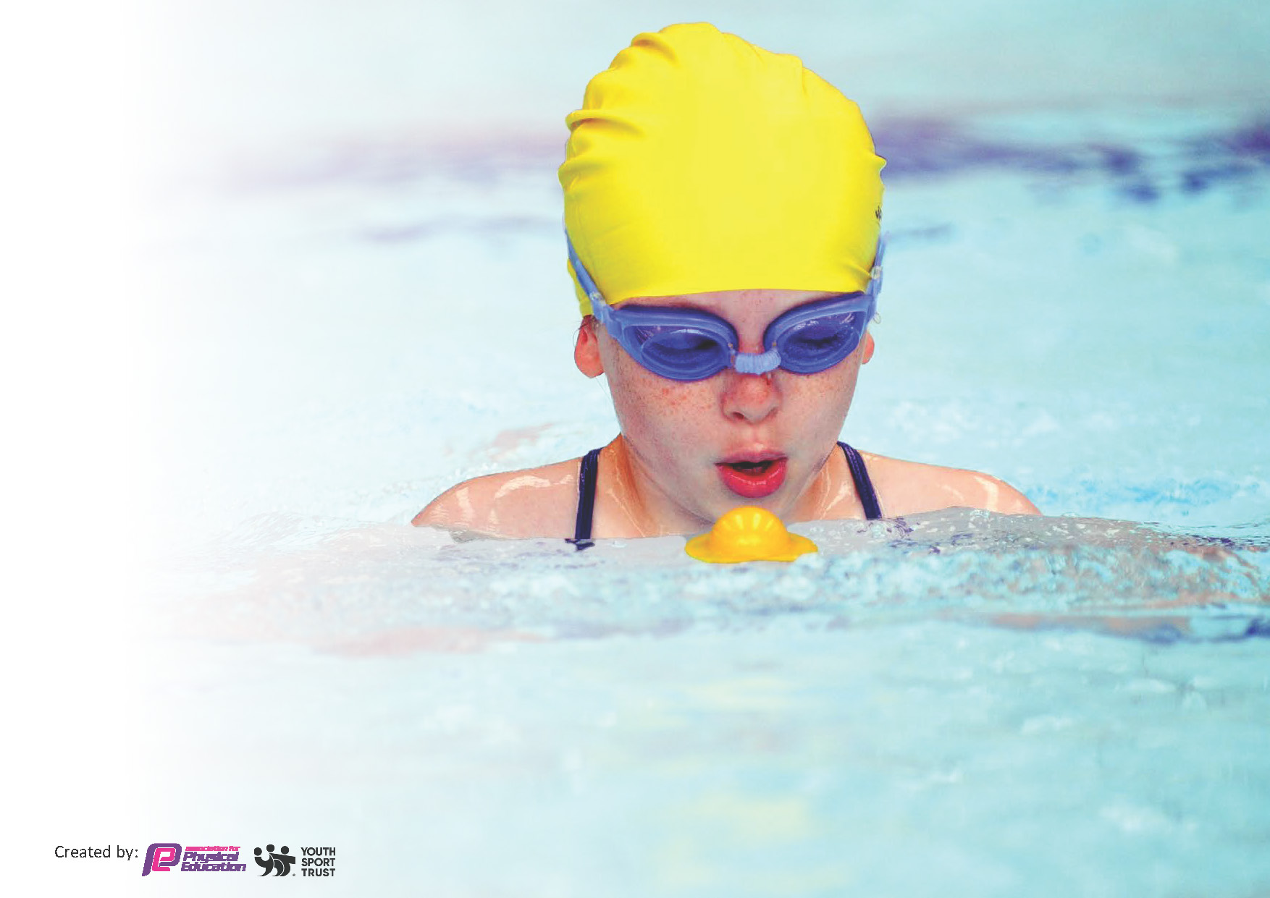
This template can be used for multiple purposes:
by:
- It enables schools to effectively plan their use of the Primary PE and sport premium
- It helps schools to meet the requirements (as set out in guidance) to publish information on their Primary PE and sport premium
- It will be an effective document to support Ofsted inspections enabling schools to evidence progress in Physical Education (PE) and evidence swimming attainment, which forms part of the PE National Curriculum. We would recommend schools consider
the Intent, Implementation and Impact of any spend, as examined within the Education Inspection Framework.

It is important that your grant is used effectively and based on school need.

Schools must use the funding to make additional and sustainable
improvements to the quality of the PE, School Sport and Physical Activity (PESSPA)
they offer. This means that you should use the Primary PE and sport premium to:

- Build capacity and capability within the school to ensure that improvements made now will benefit pupils joining the school in future years
- Develop or add to the PESSPA activities that your school already offers.

The Primary PE and sport premium should not be used to fund capital spend projects; the school’s core budget should fund these. Further detail on capital expenditure can be found in the updated Primary PE and sport premium guidance.

The Primary PE and sport premium guidance, outlines 5 key priorities that funding should be used towards. It is not

necessary that spending has to meet all the key priorities, you should select the priorities that you aim to use any funding towards.

Although completing this template is not a requirement for schools, schools are required to publish details of how they spend this funding. Schools must also outline what the impact this funding has had on pupils’ PE and sport participation and attainment and how any spending will be sustainable in the future. All funding must be spent by 31st July 2025.

The Department for Education has worked closely with the Association for Physical Education (afPE) and the Youth Sport Trust (YST) to develop this template and encourages schools to use it. This template is an effective way of meeting the reporting requirements of the Primary PE and sport premium.
Review of last year’s spend and key achievements (2024/2025)

We recommend you start by reflecting on the impact of current provision and reviewing your previous spend.

Activity/Action | Impact | Comments
Inclusion of PE coaches to support teachers in delivering high quality PE lessons.  To provide Year 6 pupils with top-up lessons for swimming.  After school clubs for a variety of supports offered weekly. | Teachers are provided with support from experts in PE when delivering lessons. Children are provided with high quality PE lessons.  This allowed skills to be further developed to ensure as many pupils are competent swimmers by the end of Year 6 as possible.  The sports rotate every half term as well as they age range. This allowed pupils to be exposed to a larger variety of sporting activities not included within our curriculum. | This has positively impacted the confidence of teachers when delivering PE lessons within the academy. This will continue into the next academic year.  The percentage of children able to swim competently by the end of Year 6 was low this year but would have been lower without the top-up sessions.  The club attendance was low in summer term. The club needs to be promoted more across school next academic year.

Key priorities and Planning (2025-2026)
This planning template will allow schools to accurately plan their spending.

Action – what are you planning to do | Who does this action impact? | Key indicator to meet | Impacts and how sustainability will be achieved? | Cost linked to the action
- To provide the children  with swimming lessons  on a weekly basis for years 2, 4 and 6.  (Funding used for Year 6  top up lessons for those  who do not meet the  standard) | Year 6 pupils | Key Indicator 2 - Engagement of all  pupils in regular physical activity. | More pupils will reach the  expected standard for  swimming by the end of  KS2. | £3,000 forecast

- After school and lunch time clubs for KS1 and KS2.  Use of a scheme to support the planning and delivery of PE lessons  To attend competitions for different sports. | Whole school  Staff and pupils  Whole school  Whole school | Key indicator 4 - Offer a broader and more equal experience of a range of sports and physical activities to all pupils  Key indicator 1 - Increased confidence, knowledge, and skills of all staff in teaching PE and sport.  Key indicator 5 - Increasing participation in competitive sport. | A range of sports offered to children which are not included in the PE curriculum. Provided by SH Active Sports  Increased confidence will be developed through a consistent approach to teaching PE across the school.  An opportunity to take part in competitive sports will be provided through communication with other primary schools in the area. | £6,930 forecast  £400 forecast  £1,000 forecast

Key achievements 2025-2026
This template will be completed at the end of the academic year and will showcase the key achievements schools have made with their Primary PE and sport premium spending.

Activity/Action | Impact | Comments

Swimming Data
Meeting National Curriculum requirements for swimming and water safety.
Priority should always be given to ensuring that pupils can perform safe self-rescue even if they do not fully meet the first two requirements of the National Curriculum programme of study

Question | Stats: | Further context  Relative to local challenges
What percentage of your current Year 6 cohort can swim competently, confidently and proficiently over a distance of at least 25 metres? | %
What percentage of your current Year 6 cohort can use a range of strokes effectively [for example, front crawl, backstroke, and breaststroke]? | %

What percentage of your current Year 6 cohort are able to perform safe self-rescue in different water-based situations? | %
If your schools swimming data is below national expectation, you can choose to use the Primary PE and sport premium to provide additional top-up sessions for those pupils that did not meet National Curriculum  requirements after the completion of core lessons. Have you done this? | Yes/No
Have you provided CPD to improve the knowledge and confidence of staff to be able to teach swimming and water safety? | Yes/No

Signed off by:

Head Teacher: | (Name)
Subject Leader or the individual responsible for the Primary PE and sport premium: | Stacey Davies (PE Lead)
Governor: | (Name and Role)
Date:

