**Weather and Climate**

**Knowledge Organiser**

**Year 4**

**Why are there different climate zones?**

**Climate zones**

**N**

**o**

**r**

**t**

**h**

**P**

**o**

**l**

**e**

These are some of the **main climate zones:**

* **tropical climate zone** – hot and wet all year
* **arid (desert) climate zone** – low rainfall and generally high temperatures
* **temperate climate zone** – generally warm summers and cool winters with moderate rainfall
* **continental climate zone** – generally cool summers and very cold winters
* **polar climate zone** – very cold temperatures all year

**Types of clouds**

Observing the **shape and height of a cloud** can also provide information to meteorologists. Di erent kinds of clouds have **special names and occur only at certain heights.**

* **Cirrus clouds** are white, feathery, and the highest in the sky.
* **Stratus clouds** are like big grey blankets of clouds and are

lower in the sky.

* **Cumulus clouds** are puffy and are the lowest in the sky.

The UK has a temperate climate.

**o**

**S**

**equator**

**e**

**l**

**o**

**P**

**h**

**t**

**u**

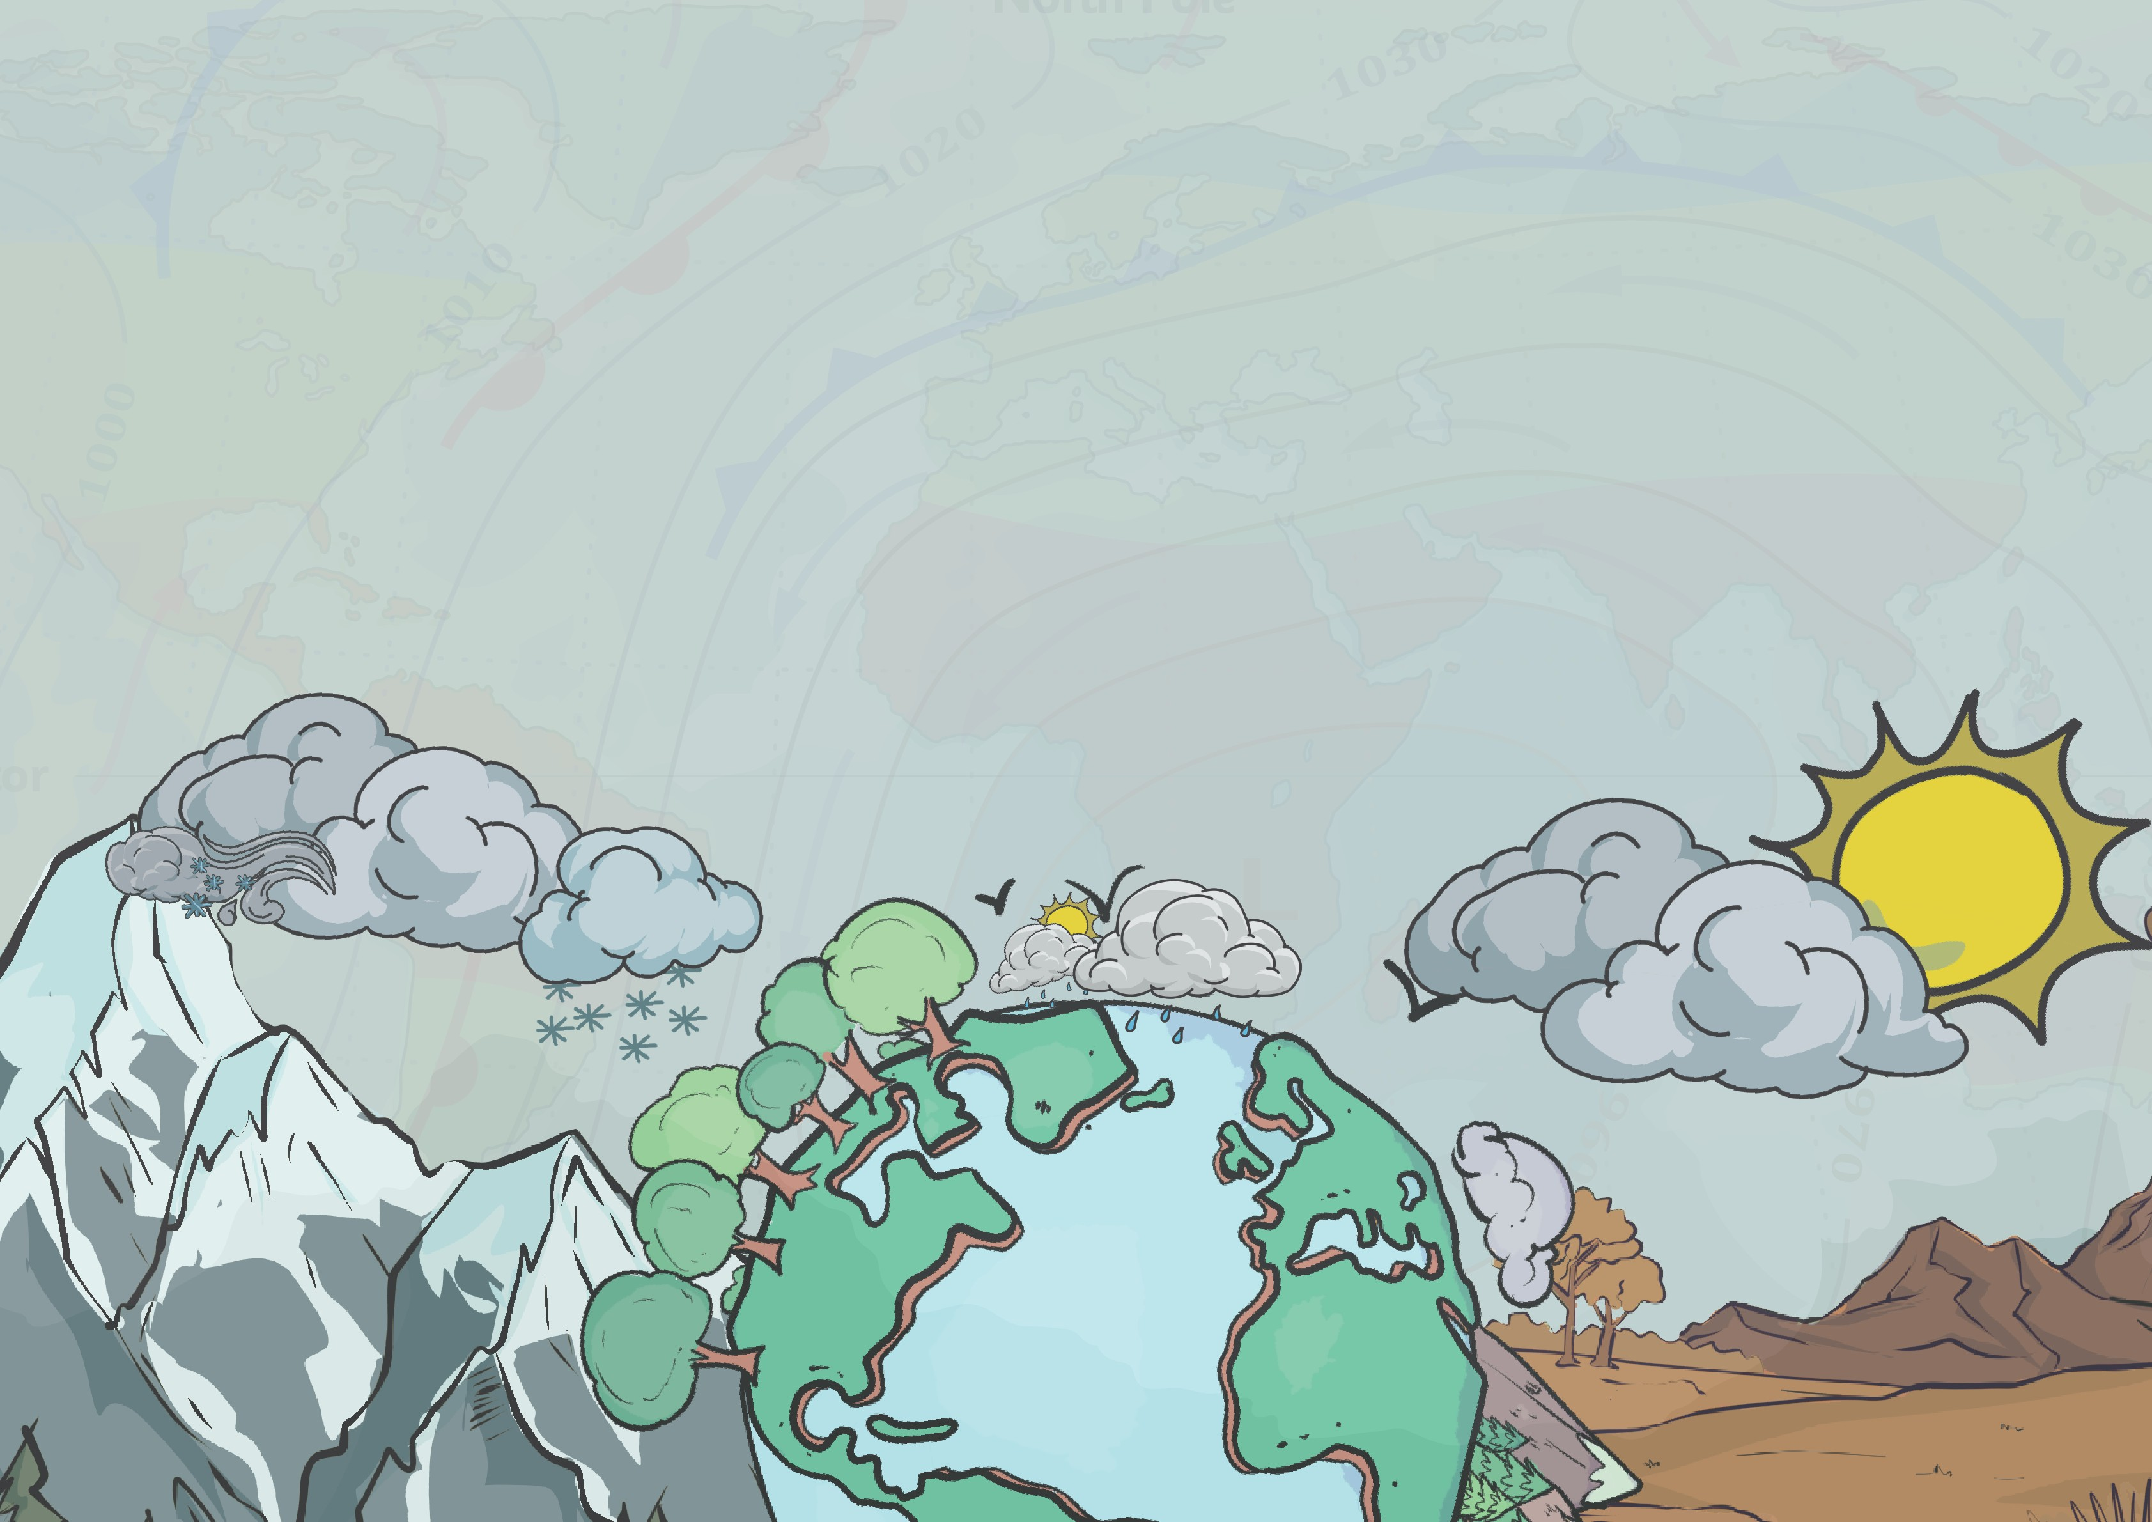

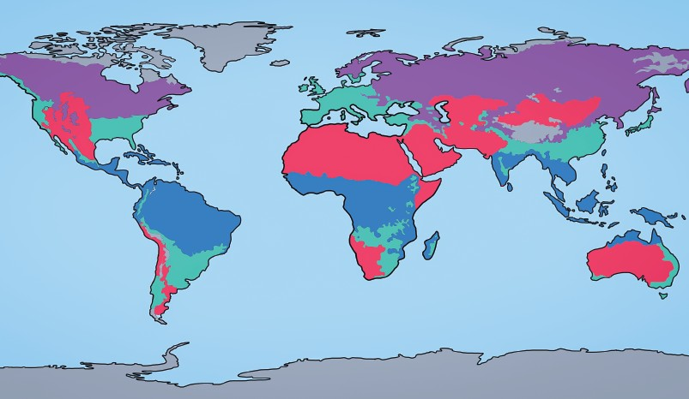

tropical

arid temperate continental polar

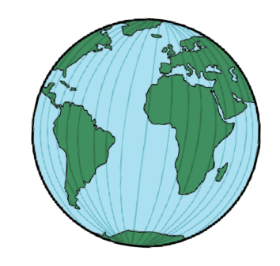

The Earth is round and **tilted at an angle**, so the Sun’s rays **don’t fall evenly on the land and oceans**. Places on the equator are the **hottest places** on Earth. They are the **closest to the Sun** and get the most **direct sunshine.**

The Sun shines less directly on the **North and South Poles** because they are f**urther from the Sun**, so they are the **coldest places on Earth.**

**S U N**

**rays from the Sun**

**• Cirrus clouds** are white, feathery, and the highest in the sky.

**• Stratus clouds** are like big grey blankets of clouds and are

lower in the sky.

**• Cumulus clouds** are puffy and are the lowest in the sky.

Observing the **shape and height of a cloud** can also provide information to meteorologists. Different kinds of clouds have **special names and occur only at certain heights.**

**Types of clouds**

**What is the difference between weather and climate?**

The climate is the **usual weather over a long period.**

The weather is the **daily changes in the conditions outside**. The weather includes the **temperature, how strong the wind is, and whether it's raining, sunny, snowing, or foggy.** The weather **can change significantly,** often **different in different seasons and places worldwide.**

There are **different climates** in large areas of the world. These areas are called **climate zones**. Where a place is on the planet will affect its weather and climate.

|  |  |
| --- | --- |
|  | **cirrus** |
|  | **stratus** |
|  | **cumulus** |



www.grammarsaurus.co.uk



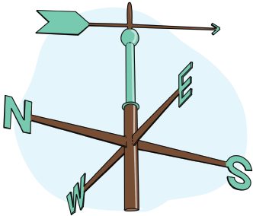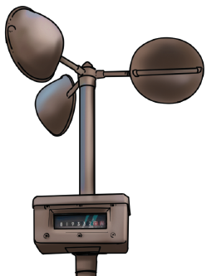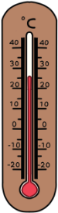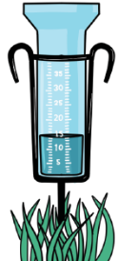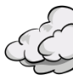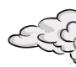

A **weathervane** measures An **okta card** measures

**wind direction. cloud cover.**

An **anemometer**

measures **how fast the wind is blowing.**

A **rain gauge**

measures

**precipitation.**

A **thermometer**

measures

**temperature.**

**Measuring the weather**

**Weather instrument placement**

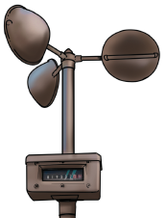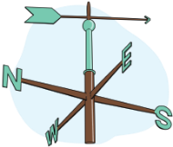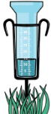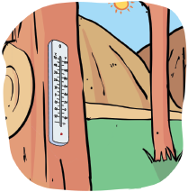

* Rain gauges should be placed in the open and not covered by a roof or branches
* Rain gauges should be placed in a cylinder or on a stake to stop them from falling over.
* Thermometers should be placed in a sheltered spot that is not in direct sunlight but not too shady
* Thermometers should be raised above the ground
* Thermometers should be placed in a secure place so that they do not get damaged
* Thermometers should be placed at the right height so you can read them.
* Thermometers should be placed in a natural area, like grass, rather than on concrete.
* Anemometers should be placed in an open area outside.
* Anemometers should be placed away from obstacles like trees or buildings that might block the wind.
* Anemometers should be placed securely so the anemometer does not move.
* Weathervanes should be placed away from trees, buildings, or anything that might block the wind.
* Weathervanes should be secured on a pole or a stand so that they can move freely.

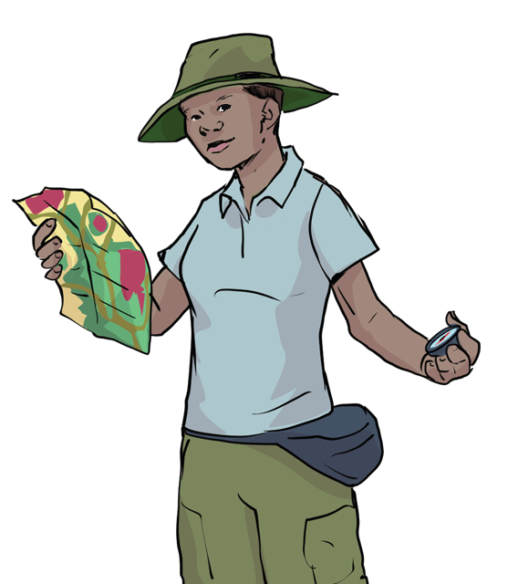

* look carefully at all the data you have presented
* try to understand them
* identify and compare patterns and trends
* explain what you have learnt about the weather in your school grounds

**average rainfall in mm**

|  |  |  |  |
| --- | --- | --- | --- |
|  |  |  |  |

|  |  |  |  |
| --- | --- | --- | --- |
|  |  |  |  |

**When you analyse your findings, you:**

**How can we present our precipitation data?**

**The numbers tell us how many mm of rain fell each month.**

**The title tells us what information the bar graph is giving us.**

**A bar chart to show the rainfall in 2022**

450

400

350

300

250

200

150

100

50

00

**This axis is labelled with the months of the year.**

**This axis is labelled to show the unit of measurement (mm).**

**The unit of measurement may change depending on your equipment.**

J

F

M

A

M

J

**month**

J

A

S

O

N

D



www.grammarsaurus.co.uk