# 

**Routes**

**Our Local Park**

**Year 1**

**Knowledge Organiser**

**Compass**



You can use this to   
**help you remember**!

**N**ever

**E**at

**S**illy

**W**orms

**point A**

N

W

E

S

**point B Primary School**

**Church Road**

**Jessica’s flat**

A route is a **way to travel from one place to another**. We can call your starting place **‘Point A’** and your finishing place **‘Point B’.**

**Love Road**

**Worcester Street**

**Liverpool Road**

Byron Road

A compass is a tool used to help find **directions**. It has a **needle** that spins, and the needle **always points north**. The **four directions** on a compass are called **cardinal points**.

**N – north E – east**

**High Street**

**S – south W – west**

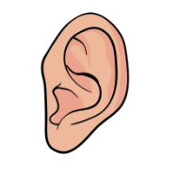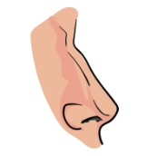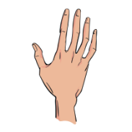

**sight**

**touch**

**smell**

**Fieldwork**

**Our senses**

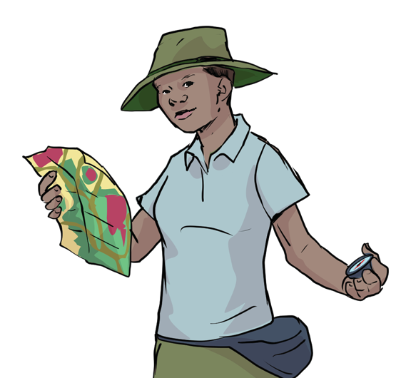**Fieldwork** is when you go outside and discover things about a place. Fieldwork includes investigating both **human and physical features**.

When conducting fieldwork, we must **ask the following questions before we carry it out**:

**hearing**

* What is the fieldwork you will carry out?

**forward**

**right**

**downward**

**left**

**Directional Language**

* Where and how will you carry it out?
* Why will you be doing it?



www.grammarsaurus.co.uk

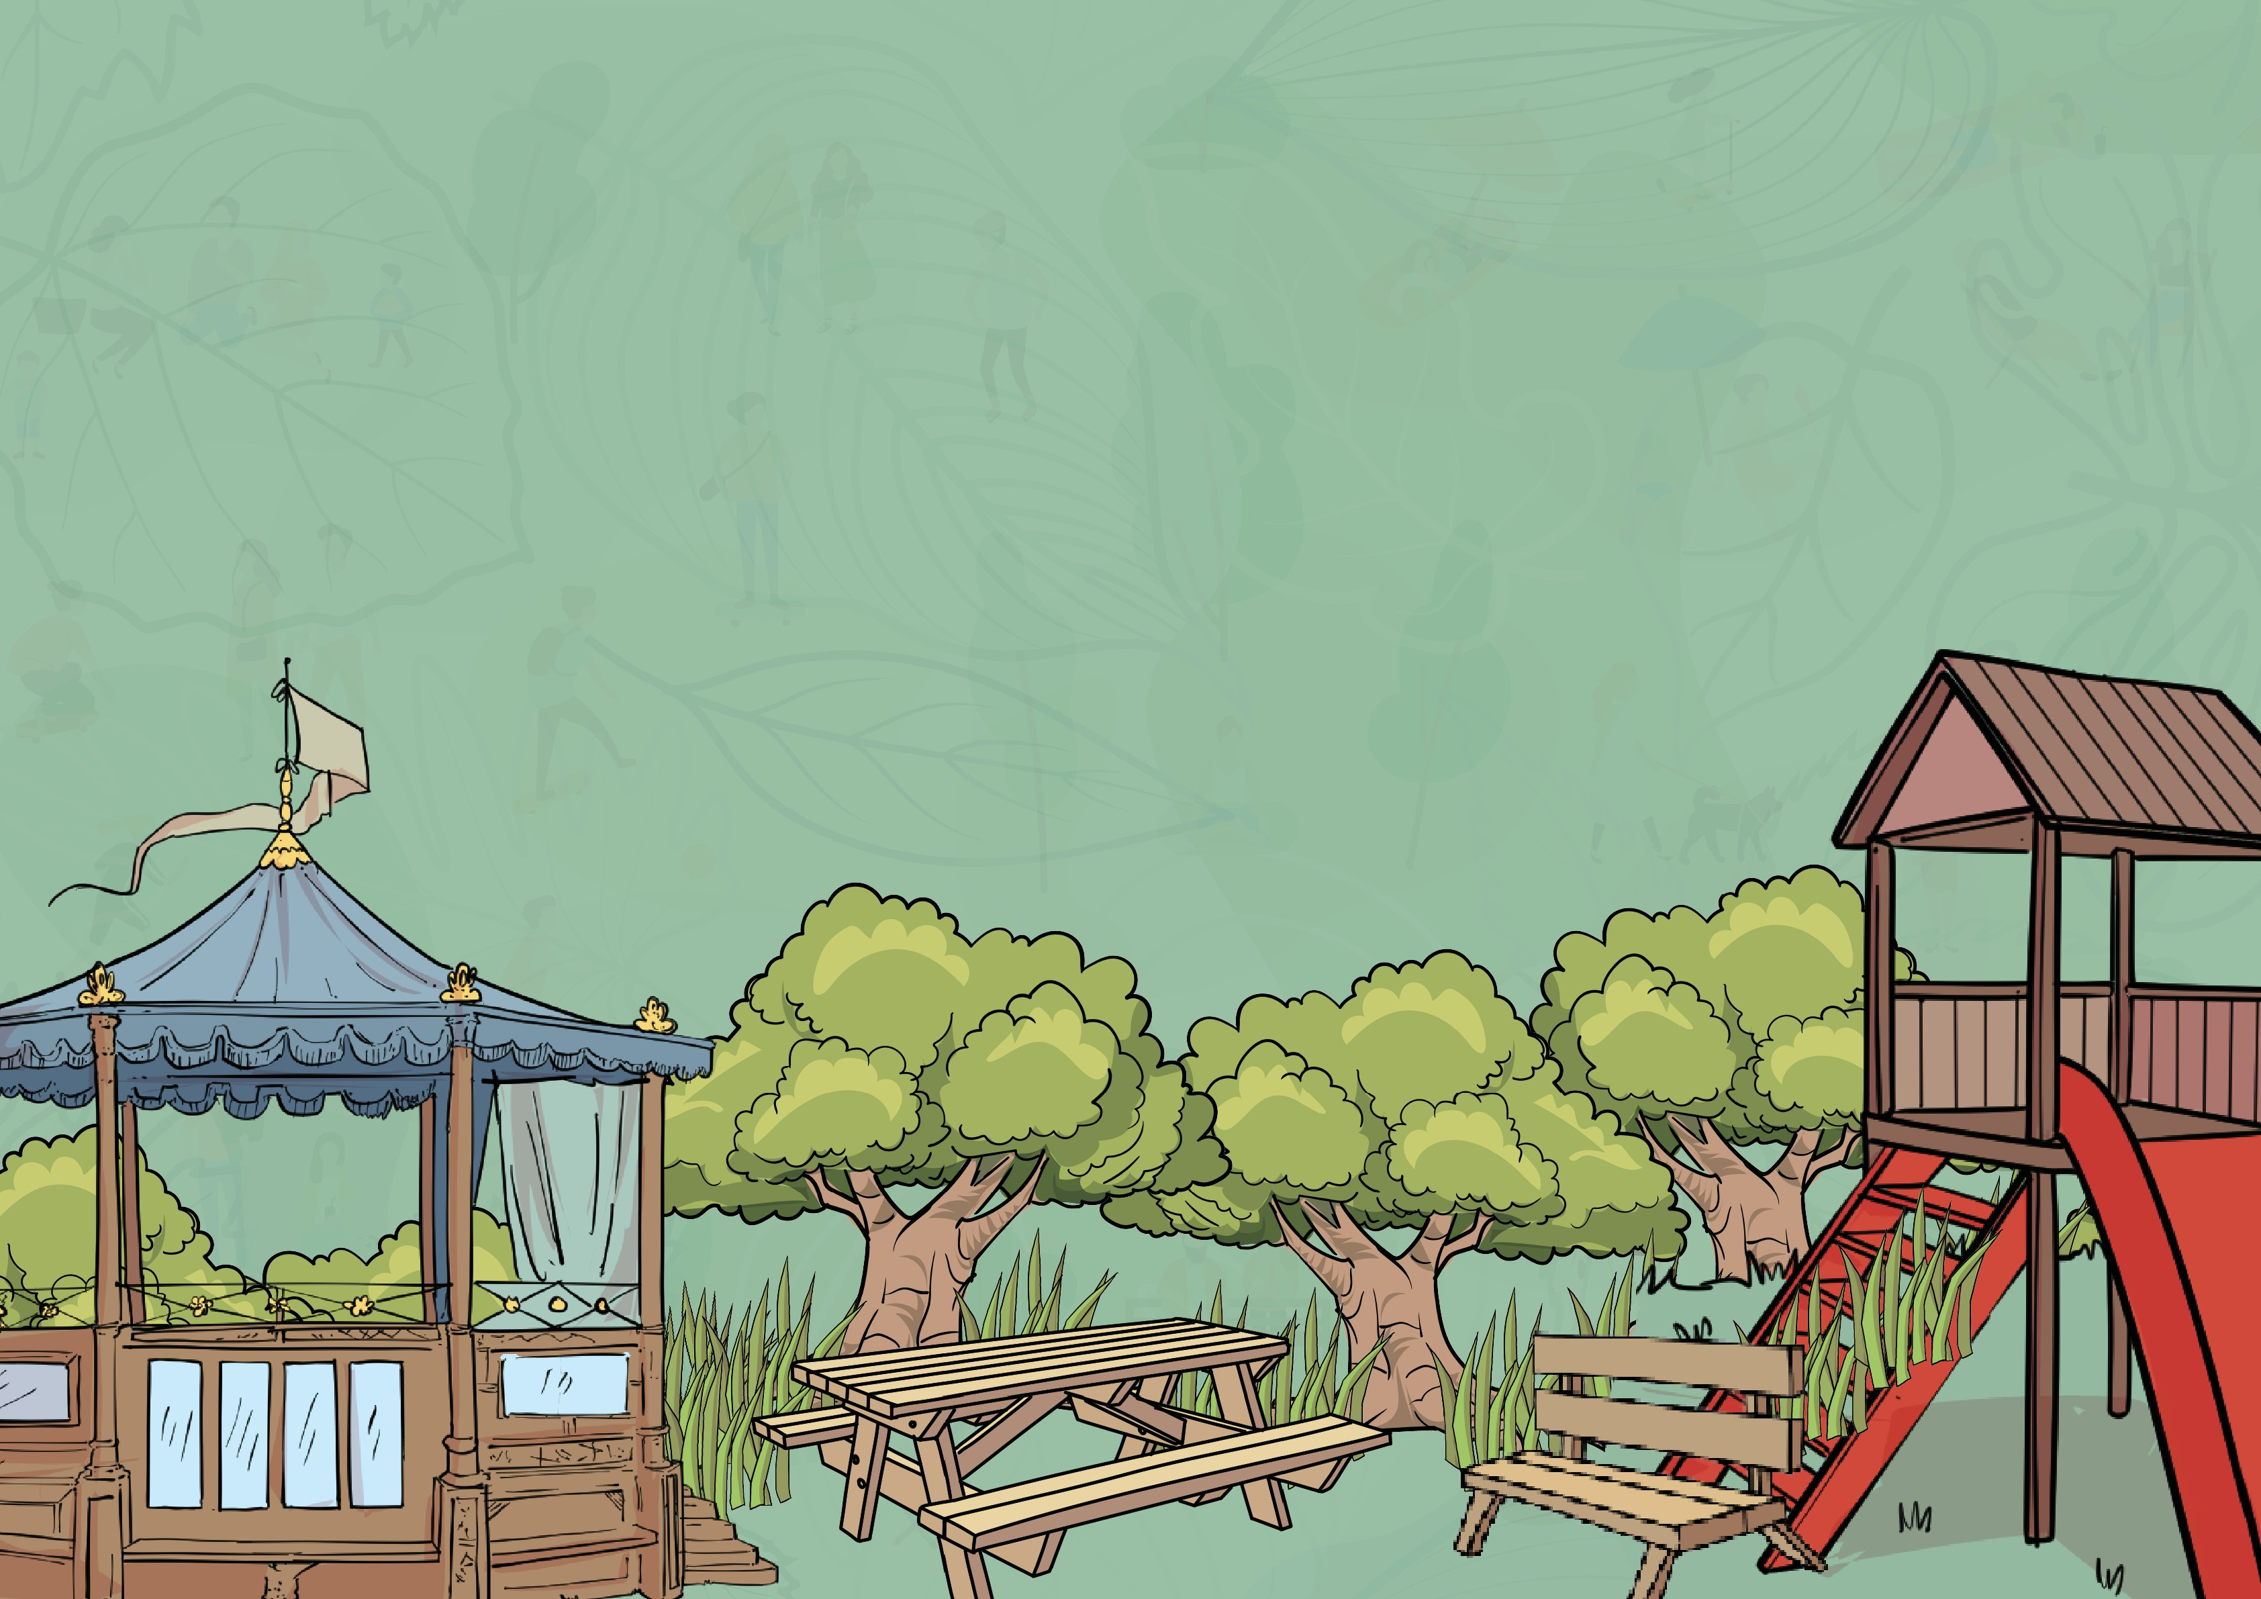

**Pictograms**

All the data collection methods can help **gather information**. We will use more than one method to collect our data!

**Data collection methods**

**Messy maps**

Follow **road safety rules**:

Remember to take your activity 1 worksheet when you visit your local park. A **clipboard** might be helpful.

* plan the safest route
* if you need to cross a road, wait until it’s safe
* watch and listen for any oncoming traffic
* be observant
* be polite

Pictograms can be used to **present data**. Here is one I have already completed for another park.

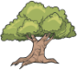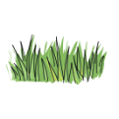

|  |  |  |  |  |  |  |  |  |
| --- | --- | --- | --- | --- | --- | --- | --- | --- |
| **Feature** | **Number of each feature** | | | | | | | **Total** |
| bench |  |  |  |  |  |  |  | 2 |
| picnic table |  |  |  |  |  |  |  | 3 |
| grass area |  |  |  |  |  |  |  | 2 |
| tree |  |  |  |  |  |  |  | 7 |
| hill |  |  |  |  |  |  |  | 1 |
| pond |  |  |  |  |  |  |  | 0 |
| play area |  |  |  |  |  |  |  | 1 |

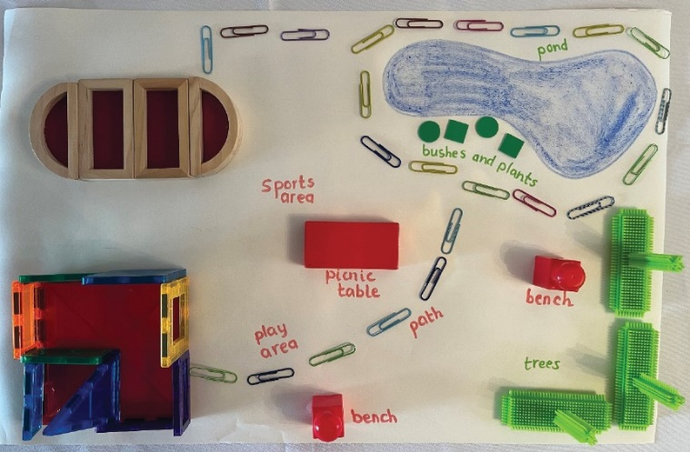

Messy maps are maps created out of **lots of different materials**. You can use things you find in your classroom, like **blocks, Lego, boxes, cubes, skipping ropes, beanbags etc.**

Messy maps must include all the **important parts of the location** you are mapping.

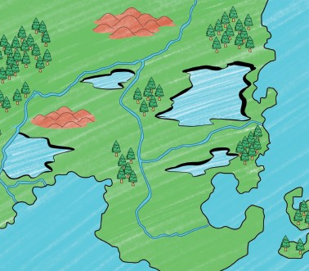

**observational sketches** of geographical feature

**digital photographs** are taken to observe geographical features

**questionnaires** asking questions to local people

**tally charts** counting geographical features

**Road safety**



www.grammarsaurus.co.uk