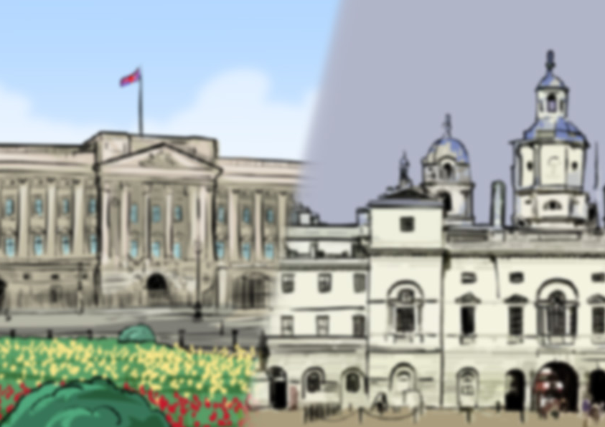

**Kings, Queens, Castles and Palaces**



**KS1**

**Knowledge Organiser**

**A timeline to help us:**

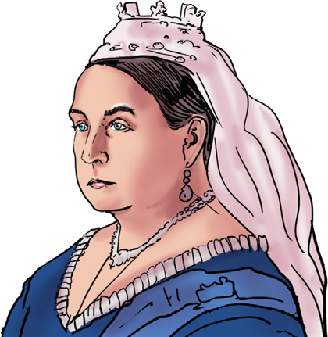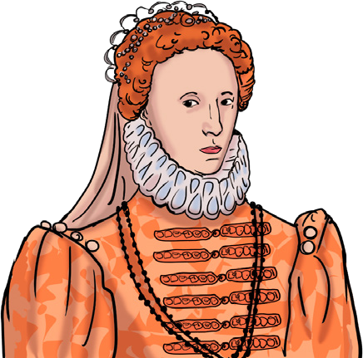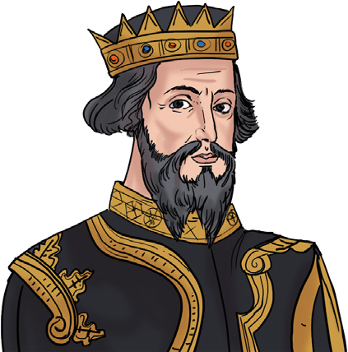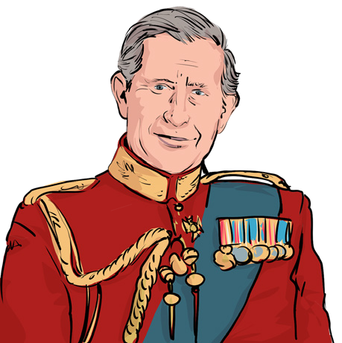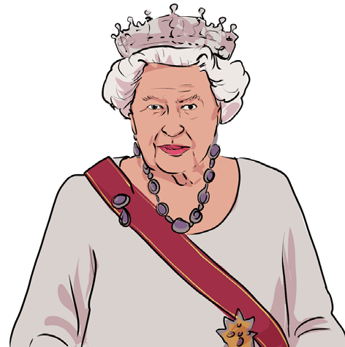

|  |  |  |  |  |
| --- | --- | --- | --- | --- |
| **King William I 1066** | **Queen Elizabeth I 1558** | **Queen Victoria 1837** | **Queen Elizabeth II 1952** | **King Charles 111 2022** |



70 years ago from the present day

115 years before that

279 years before that

492 years before that

**king before now moat defend monarch**

**then**

**queen past different**

**battlements protect change**

**attack**

**reign present significant drawbridge monument**

**castle**

**Key vocabulary to help us:**



**We can find out about the past by:**

* looking at and reading non-fiction books
* searching the internet
* talking to people who were around at the time that we want to learn about
* watching video clips or TV shows about the time in history we want to find out about
* visiting museums
* looking at photographs
* looking at objects from the past www.grammarsaurus.co.uk

**How do we find out about the past?**

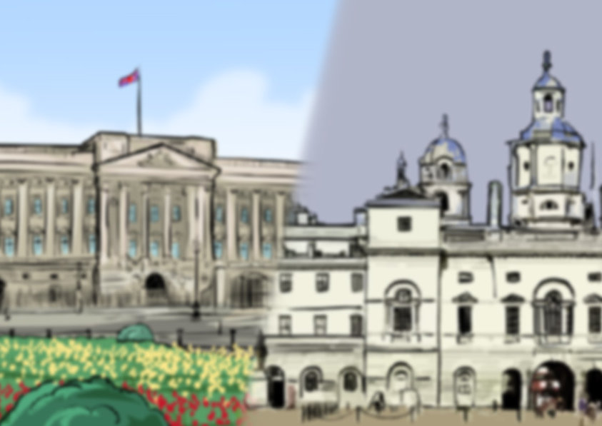

**Castles and Palaces**

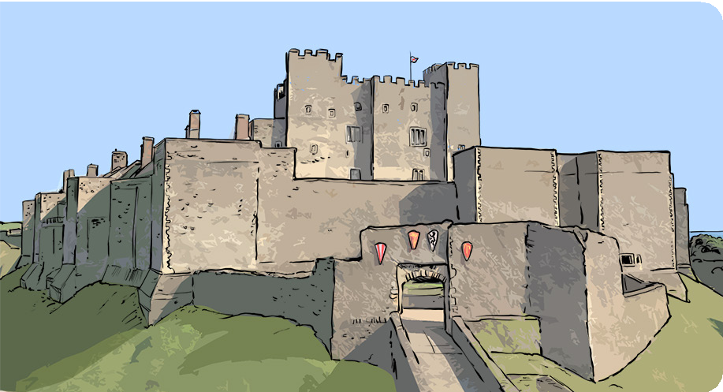

Kings and queens live in castles and palaces. They were:

* built for important people, their families and servants
* built to protect important people from attack
* often built high up on a hill so that any attackers could be seen
* often very big to show how much money the important person had
* designed to launch weapons to attack the enemy

**Castles**

**The present-day**

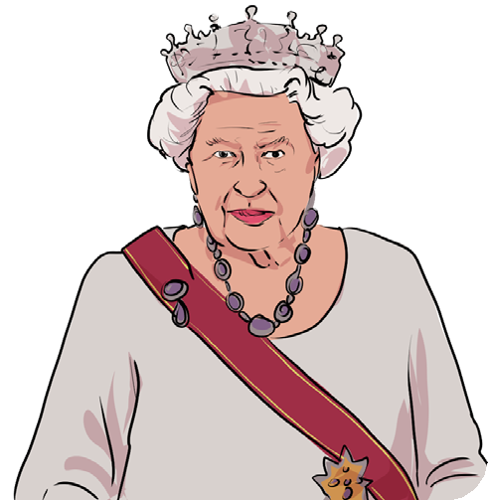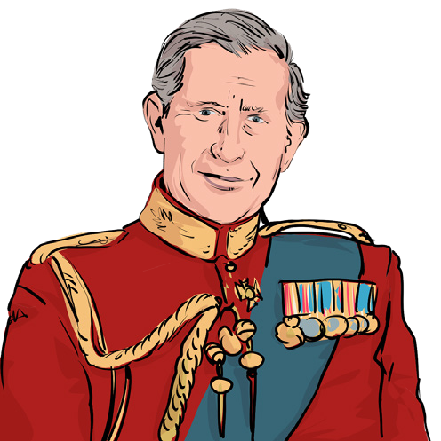

King Charles III is the present-day king of England. He came to the throne in 2022 after the death of his mother, Queen Elizabeth II. Queen Elizabeth reigned for 70 years, meaning she is the United Kingdom's longest-reigning monarch. The castles and palaces that were significant in the Queen's reign were:

* Buckingham Palace
* Windsor Castle
* Balmoral Castle in Scotland

These are royal residences that the king is thought to spend time in now he is the reigning monarch.

These lessons will look back almost 1000 years to the reign of the first King of England, William I. He reigned in the year 1066 after winning the Battle of Hastings. He is also known as William the Conqueror. Between William I and the present-day King Charles III, there have been 41 other Kings and Queens of England. Some of the most famous ones are Queen Elizabeth I and Queen Victoria.

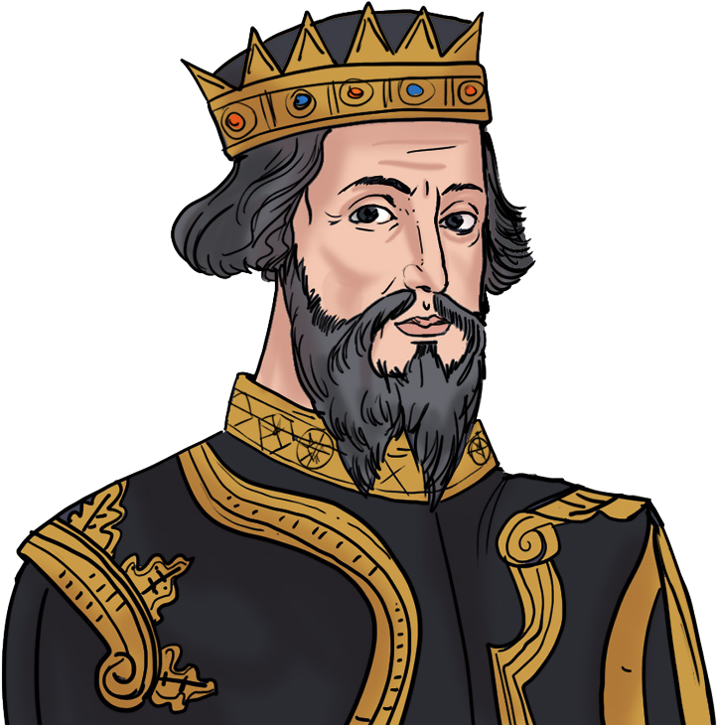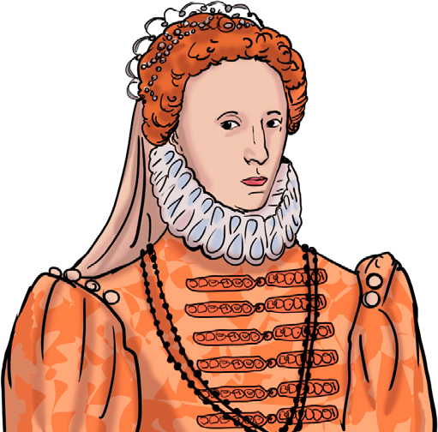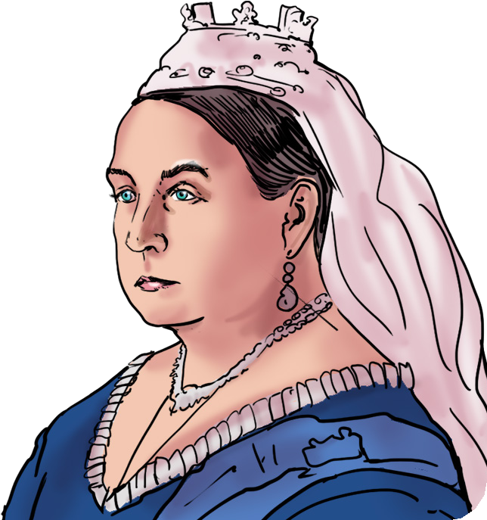

**The past**

www.grammarsaurus.co.uk