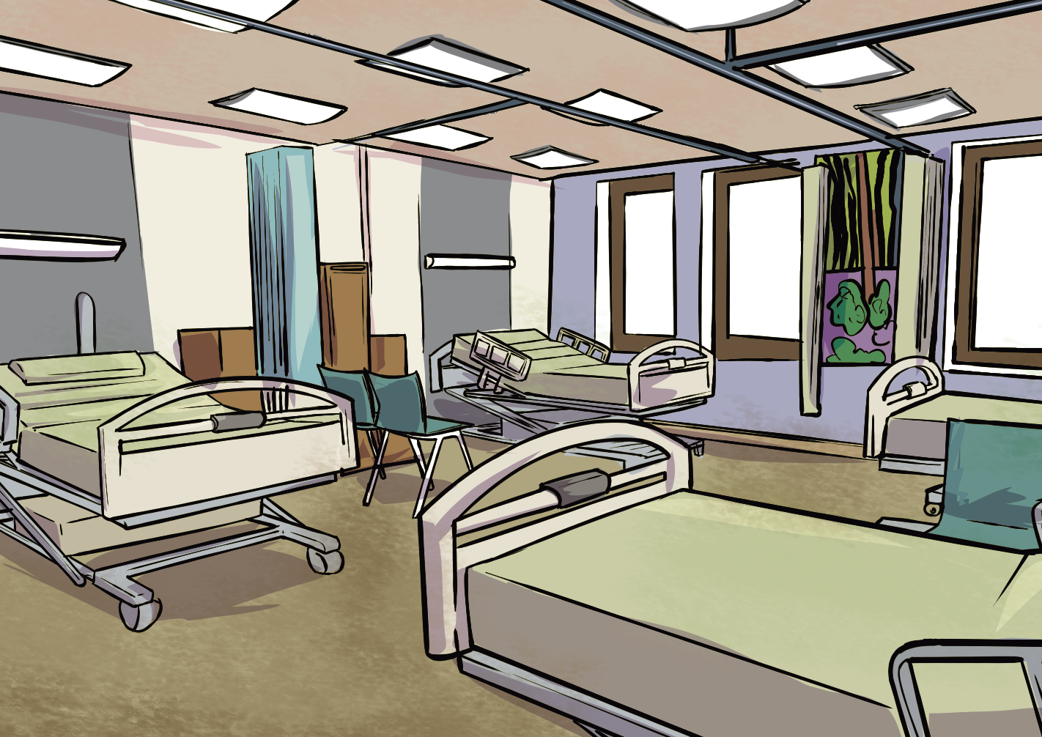Hospitals and Healthcare

**Knowledge Organiser**

**Year 2**

# A timeline to help us:



Let’s use a **timeline** to show when Florence and Edith **became nurses**.

**2022**

**2002**

**1992**

**1982**

**1962**

**1952**

**1942**

**1932**

**1912**

**1902**

**1892**

**1882**

**1862**

**1852**

**1842**

**1832**

**1822 1872 1922 1972 2022**

200 years ago 150 years ago 100 years ago 50 years ago today, now,

present day



Florence Nightingale became a nurse in **1851**.

Edith Cavell became a nurse in

**1896**.

The NHS (National Health Service) was **founded**.

# Key vocabulary to help us:



**before** - at an earlier time

**after** - later in time

**past** - having happened or gone by at an earlier time

**present** - happening now, at this time

**similar** - something that is like something else, but not identical **compare** - note the similarities or differences between things **then** - at that past time

**now** - in these times, or at this time

**modern** - relating to the present

# How do we find out about the past?

**We can find out about the past by:**

* looking at and reading non-fiction books.
* searching the internet.
* talking to people who were alive at the time we want to learn about.
* watching video clips or TV shows about the time in history we want to learn about.
* visiting museums.
* looking at photographs.
* looking at objects from the past.

www.grammarsaurus.co.uk



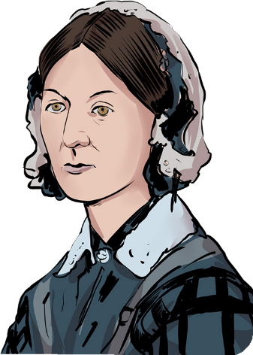

**Florence Nightingale**

Florence was a British **nurse**.

Florence went to the **war in Crimea** to help treat the wounded soldiers, and she was appalled by the filthy conditions in the military hospital. She insisted that all nurses and doctors **wash their hands** before treating patients.

This helped to stop the spread of disease and saved many lives. Florence looked after these soldiers even into the night when it was dark. She would walk up and down with a light. She was famously known as the ‘**Lady with the Lamp**.’

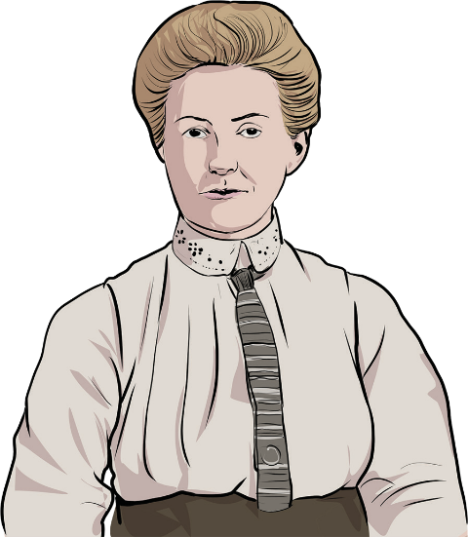

**Edith Cavell**

Edith was a British **nurse**. At the start of **World War 1**, Edith cared for many wounded soldiers, including many German soldiers, at the Red Cross Hospital. She thought that everyone had the right to medical treatment, no matter which country they were from.

Edith helped more than **200 soldiers escape** to safety during the war. She was arrested and sentenced to **death as punishment**.

Before her death, Edith said, ‘**I must have no hatred or bitterness towards anyone**.’

**The NHS**

**The National Health Service** (NHS) that we have in our country was introduced in **1948**. The fundamental values of the NHS are: **patients always come** first. **Everyone is respected** and **valued**, and care and compassion are at the centre of all treatment. **Everyone counts**. **Nobody is discriminated against**.

**Cleanliness** and **good hygiene** in hospitals are vital to keeping patients safe. Without clean hospitals and good hygiene routines, like regular hand washing, diseases would spread, and infections would be dangerous for everyone.



www.grammarsaurus.co.uk