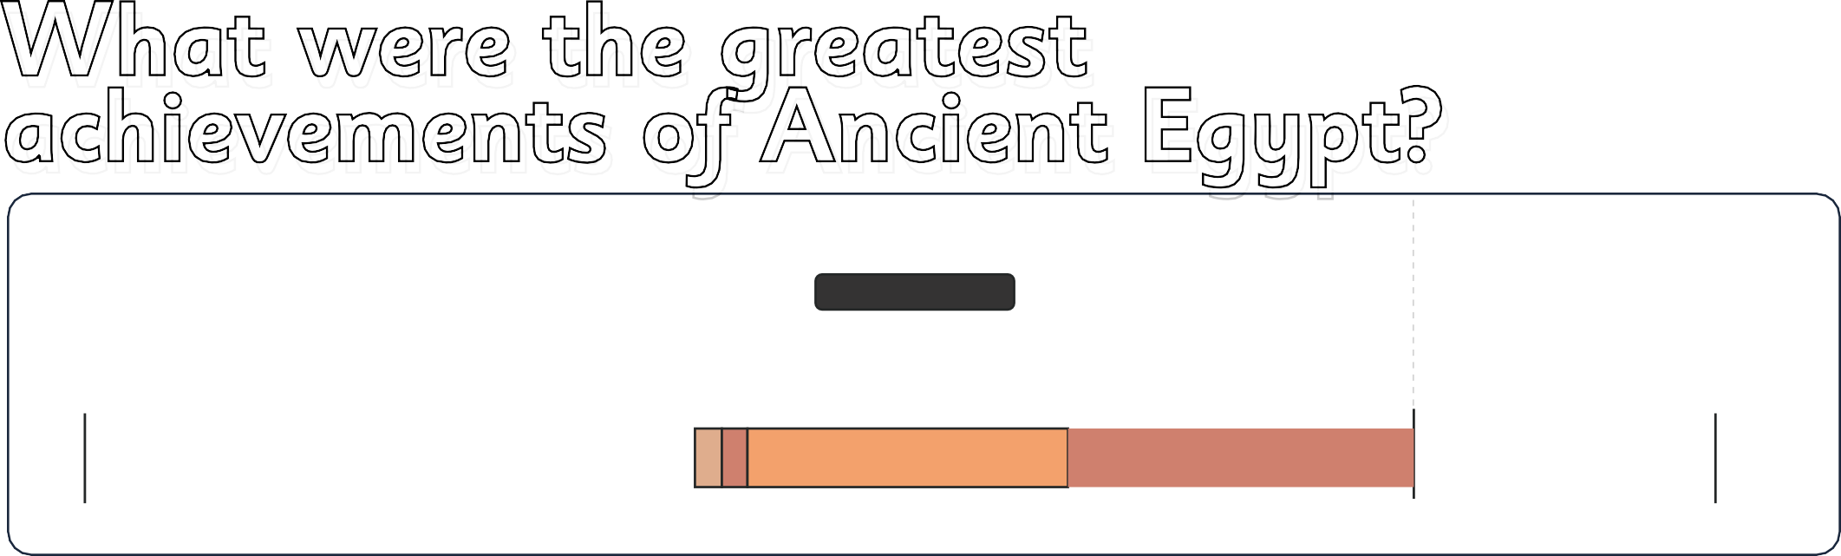What were the greatest achiev



**Knowledge Organiser**

**Year 3**

**What were the greatest**

**achievements of Ancient Egypt?**

# Knowledge Organiser

**Year 3**

Ancient

Egypt

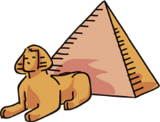

Ancient Egypt

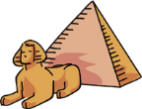

Old Kingdom

2560 BCE

Great Pyramid of Giza complete

River Nile used to irrigate crops

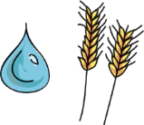

332 BCE

Alexander the Great conquers



30 BCE

Cleopatra dies

Ancient Egypt

Early Egypt

Conquered Egypt

Middle Kingdom and New Kingdom

2,000,000 BCE

2575 BCE

**vocabulary**

era artefact scribe pharaoh hierarchy

hieroglyphics Egyptologist chamber pyramid chariot invade empire polytheistic temple

obelisk

**Key historical**

2150 BCE

30 BCE

1000 CE

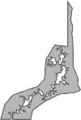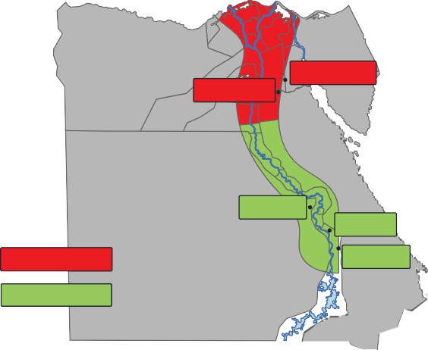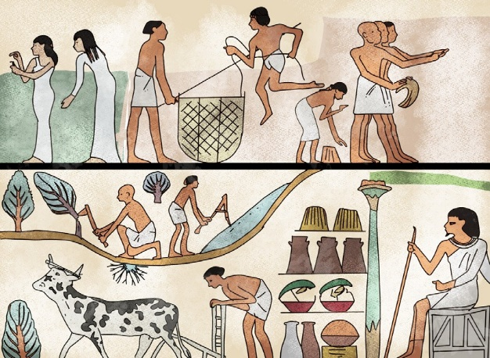

**The Ancient Egyptian civilisation**

**How do we know about the Ancient Egyptians?**

People have lived in Egypt since the beginning of the Stone Age in Britain. By 5000 BCE, they migrated near the **River Nile**, where they began living in large villages. These settlements grew to create an ancient civilisation which would last thousands of years!

Ancient Egypt used to

We know about the Ancient Egyptians because of **evidence** left behind from that era, such as **wall art**, ancient Egyptian **writing** and **artefacts**. These have been discovered by archaeologists and studied by experts.

The Ancient Egyptians used **hieroglyphics** to write things down. These are symbols that represent sounds or words.

be split into two parts – **Upper Egypt** and **Lower Egypt**.

**Memphis**

**Heliopolis**

**Lower Egypt Upper Egypt**

**Abydos**

**Thebes Nekhen**

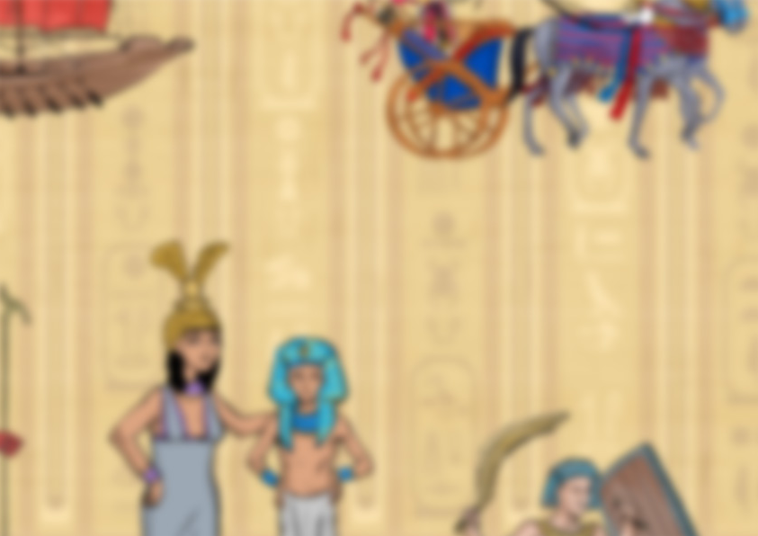

www.grammarsaurus.co.uk

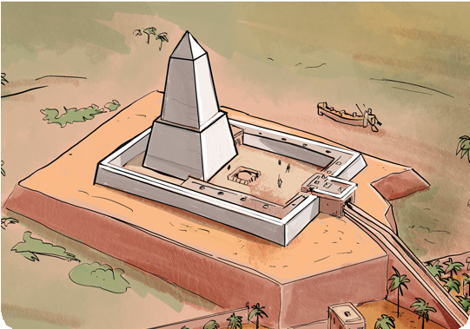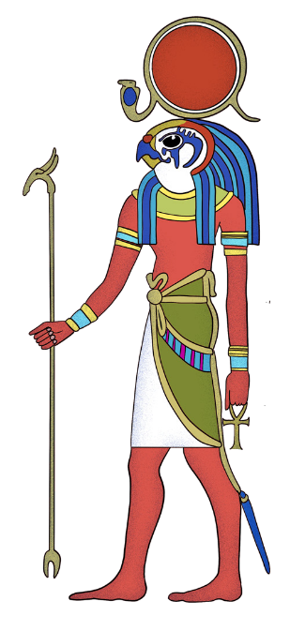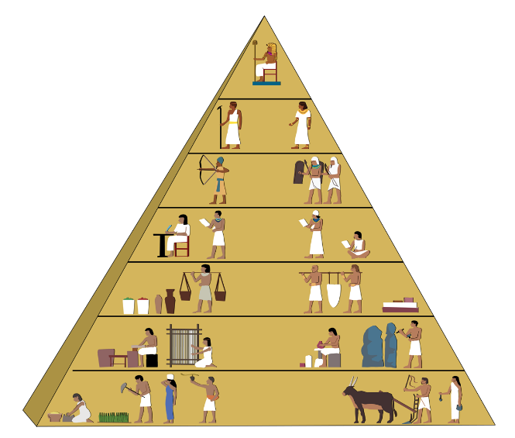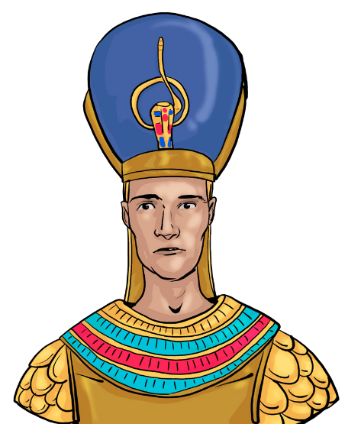

**Ancient Egyptians?**

**Who ruled the**

**Who did the Ancient**

**Egyptians worship?**

**What are the Ancient Egyptians remembered for?**

There was a **hierarchy** in Ancient Egypt. People with certain jobs were more important than others. The **pharaoh** was the most important person in society.

Farmers and enslaved people were considered the least important in society.

**pharaoh**

**government officials, nobles, priests soldiers**

**scribes**

**merchants craftsmen**

**farmers and slaves**

Ancient Egyptians were **polytheistic**, which means they worshipped more than one god. Each god ruled an aspect of life. In the Old Kingdom, **Ra** (the Sun God) was the most important.

Ancient Egyptians worshipped their gods in special buildings called **sun temples**. These were built as holy places to worship and to offer their prayers.



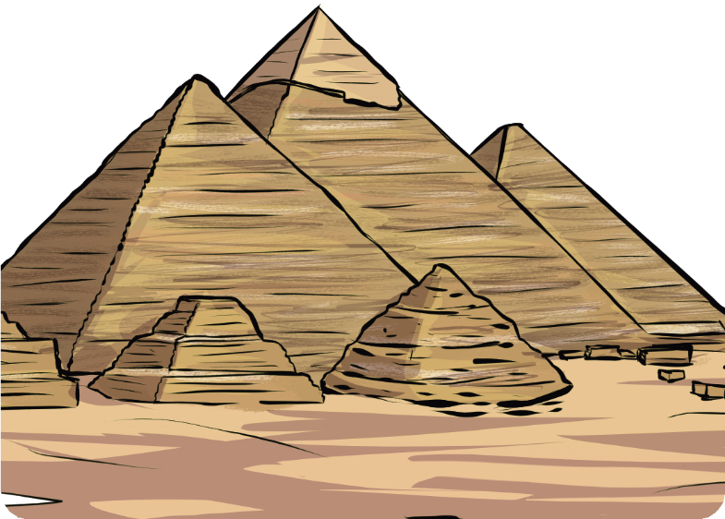

**What are the Ancient Egyptians**

**remembered for?**

Many people associate the **pyramids** with the Ancient Egyptians. These still stand today!

Pharaohs wanted their journey to the **afterlife** to be a special event, so they ordered giant pyramid structures to be built. Their bodies were placed inside these when they died.

The largest pyramid ever built was the **Great Pyramid of Giza**, and there are many theories on how this was built.

Archaeologists used to believe that enslaved people built the Great Pyramid of Giza, but they now think that skilled artisans were given the job of building it instead.

**Ramses II** was one of the most powerful pharaohs who ruled for **66 years**.

www.grammarsaurus.co.uk