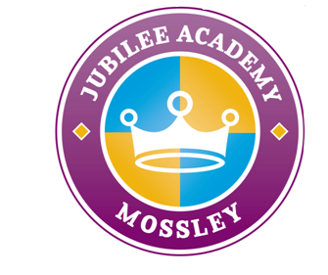 

The Safeguarding Team

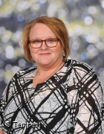   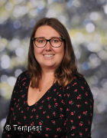

If you have a concern about a child, please see a member of the safeguarding team. Thank you.

Joe Westwood Deborah Drohan Kate Benton Laura Hood

*Assistant Principal/DSL* Family *& Multi-Agency Principal Assistant Principal (Designated Safeguarding Liaison Co-ordinator*

*Lead) /DDSL/Wellbeing Champion*

 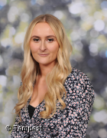 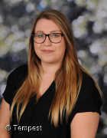 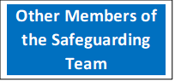

Katie Mason Stacey Westwood Rachael Owen

*Office Manager/ DEI Lead Champion Staff Wellbeing Champion*

*attendance lead (Diversity, Equity and Inclusion)*