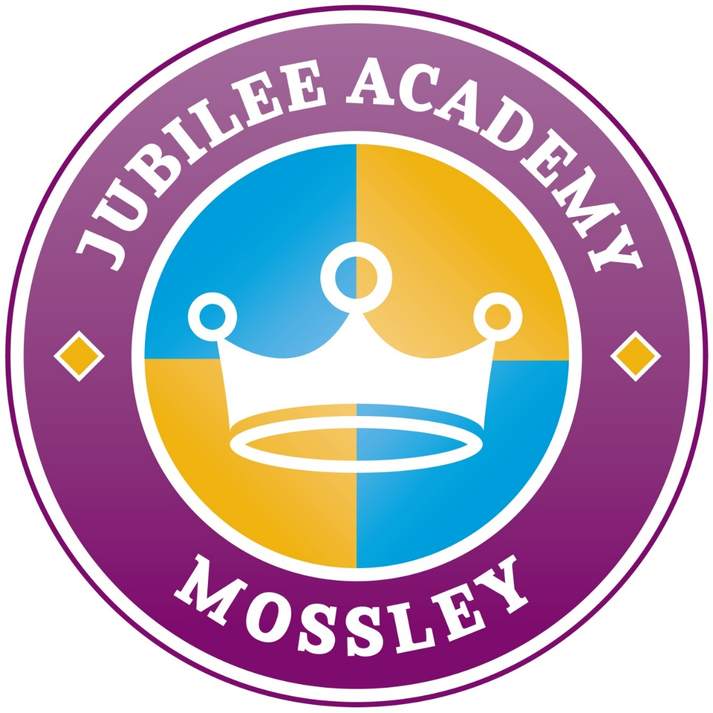
Induction Information
Pack

Welcome to Jubilee Academy!

Jubilee Academy is ‘Good’!

Life at Jubilee Academy is fun, enjoyable and enriching and we are very, very proud of each of our children. We continue to work hard to inspire every child in our school to succeed and develop. We pride ourselves on our varied, enriched curriculum and the confidence and achievements of our pupils.

We want the children who attend Jubilee Academy Mossley to leave us in Year 6 with the skills and positive thinking needed to achieve their ambitions and to lead happy, successful lives. We offer an exciting, hands-on learning experience that is tailored to the needs of all our children. You will often find them using a broad range of devices including iPads and laptops, making music in the Rock It Project and having their say about school through our Junior Leadership Team.

We encourage you to visit our academy website which contains important information including our policies, term dates and schemes of learning.

Vision Statement

Together we will succeed

We believe that every child is important and deserves a first class education. We believe everyone has hidden potential to be uncovered and nurtured. We aim to inspire every child in our school to succeed and seek to provide them with the opportunities to develop to their full potential. We pride ourselves on our varied, enriched curriculum and the confidence and achievements of our pupils. We want the children who attend Jubilee Academy Mossley to leave us with the skills and positive thinking needed to achieve their ambitions and to lead happy and successful lives. To achieve this vision we:

TEACHING & LEARNING
- Have high academic expectations
- Encourage children to become independent learners
- Provide a varied and enriched curriculum
- Enhance our children’s learning experiences through a wide range of exciting, challenging and extra-curricular activities

SOCIAL
- Recognise individual and school success and focus on the positive
- Have respect for each other and resources
- Foster an atmosphere of honesty and trust
- Show happiness, stability and continuity
- Communicate effectively with all stakeholders of the school
- Strive for high self–esteem in all of our children
- Encourage involvement in all aspects of school life
- Build team-spirit through sports, music, arts and extra-curricular activities

SCHOOL ENVIRONMENT
- Maintain a secure environment
- Provide a happy and stable environment
- Provide a stimulating and effective environment
- Create a caring environment
- Promote a healthy life-style

COMMUNITY
- Are actively involved in the community
- See parents as partners in their child’s education
Our Staff

From September 2023:
Office & Pastoral
Office Manager - Miss Mason
Office Admin - Miss Baggott
Pastoral - Mrs Drohan
Caretaker - Mr Allmark

Year 1
Teacher - Mrs Owen
Teaching Assistants - Mrs Leonard,
Miss Sparkes & Mrs Picken

Year 3
Teacher - Miss Ward
Teaching Assistants - Mrs France
& Miss Tipton

Year 5
Teacher - Miss Westwood
Teaching Assistants - Miss Wood
& Mrs Parkes

Across School
HLTAs – Miss Wood & Mr Phillips

Senior Leadership Team
Principal - Mrs Benton
Assistant Principals - Mrs Westwood &
Miss Hood (maternity leave)

Reception
Teacher - Miss Jones
Teaching Assistants - Miss Matthews
& Miss Pugh

Year 2
Teacher - Miss Dolman
Teaching Assistants - Mrs Withey
& Miss Clarke

Year 4
Teacher - Miss Gill
Teaching Assistants - Miss Rogers
& Mrs Roscoe

Year 6
Teacher - Mrs Whitehouse
Teaching Assistants - Mrs Smith
& Miss Morris

Our School Day

Class | Start school | Enter via | Finish School | Collect from
Reception | 8.40am-8.45am | Grey Door | 3.05pm | Classroom Door
Year 1 | 8.40am-8.45am | Classroom Door | 3.10pm | Classroom Door
Year 2 | 8.40am-8.45am | Classroom Door | 3.10pm | Classroom Door
Year 3 | 8.40am-8.45am | Classroom Door | 3.15pm | Classroom Door
Year 4 | 8.40am-8.45am | KS2 Door | 3.15pm | KS2 Door
Year 5 | 8.40am-8.45am | KS2 Door | 3.15pm | KS2 Door
Year 6 | 8.40am-8.45am | KS2 Door | 3.15pm | KS2 Door

To improve access and ease of navigating the site we ask that parents of Reception, Year 1 and Year 3 use the main intercom gate by the office to enter and exit through the Mossley Lane Gate and parents of Year 2, Year 4. Year 5 and Year 6 use the Tintern gate by the carpark and exit through the Mossley Lane Gate.

Any children who arrive after 8.45am must be brought by an adult to the school office to be signed into school and taken to class. This will be recorded as a ‘L’ coded late mark. Children who arrive after 9.30am will be recorded as late with a ‘U’ coded mark which is classed as an unauthorised absence. Please note, this will not be used for medical appointments where confirmation has been seen when a child comes in afterwards.
School Meals
School meals will remain free of charge to all children in Reception to Y2. Children in Y3 upwards will need to pay for meals unless you are in receipt of Free School Meals - Dinners cost £2.55 a day (£12.75 per week) which must be paid via School Money in advance or at the end of each week. If you think you may be eligible for Free School Meals please apply online via Walsall Council.
Uniform

We think uniform not only looks smart but also helps children to concentrate on what really counts - learning something new every day! All children are expected to be in the full, correct uniform every day. This includes plain black school shoes and a school PE kit. All uniform will be checked daily to ensure it meets our policy - where it doesn’t meet the policy parents will be contacted.

Please ensure that all uniform has your child’s full name clearly labelled in it - the back of the badge is a good place to use for jumpers. We have numerous uniform that goes missing daily and we are unable to locate or find jumpers, cardigans etc if they are not clearly labelled with your child’s name to identify it as theirs.

Children can wear a pair of stud earrings but any hoop earrings, rings, bracelets, necklaces and gel/stick on nails are not permitted for health and safety reasons as if these get caught outside on the equipment they pose a serious injury risk. If your child wears earrings on a PE day they will need to remove them by themselves and be responsible for looking after them.



A purple jumper or cardigan available from Crested Schoolwear

A white polo shirt and black trousers, skirt, shorts, pinafore or purple check dress


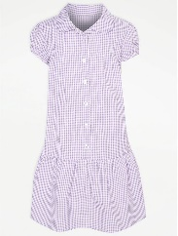

Plain black school shoes
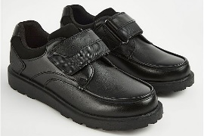
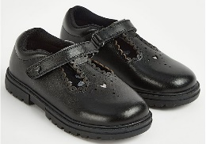

PE Kit
A purple PE top and black shorts (joggers in winter) and pumps or trainers



Absence & Lateness

We follow Public Health England guidance for absences. Some of the most common illnesses are listed in the table below. The full guidance is available from Public Health England.
Regular school attendance brings enormous benefits to individual pupils, their families, schools and the community as a whole. Without regular attendance, levels of attainment suffer and opportunities are missed to obtain maximum benefit from education.

Persistent absence and lateness will affect a child’s achievement and progress in school. Comprehensive research shows that there is a direct link between a child’s level of school attendance and their level of school attainment.

As a parent it is your legal responsibility to ensure your child receives a suitable full-time education. It is your responsibility that your child attends school each day and is on time. It is important to set the expectation of good attendance right from the beginning of school so children grow up with ‘good habits’.

If your child is absent from school you must inform the school, by telephone or Dojo, giving a reason for the absence by 9.15am.

Absences once reported are either authorised or unauthorised by the school.

Authorised absences would include time off for religious observance, medical appointments and genuine illness. Please note that the school has the right to ask for proof of medical appointments and confirmation from a medical professional if a child’s level of absence is above that expected for a usually healthy child.

Unauthorised absences would include time off for birthday treats, family days out, holidays etc.

If your child is late to school you must bring them to the office. You will now need to record your child’s reason for lateness on our system.
If you child arrives late they will be asked to make up any lost learning from the morning during their break and lunchtime to ensure they are not missing key knowledge.
If your child is persistently late a Team around the Child meeting will be held to discuss the barriers to prompt attendance with all professionals involved.
Any child arriving after 8.45am will be marked late.
.

Illness / Infection | Period to be away from school
Chicken Pox | 5 days from the onset of the rash & until all spots have scabbed over
Hand, foot and mouth | None, attend as normal
Impetigo | 48 hours after starting antibiotics or if not having antibiotics when all sores are scabbed over
Scarlet Fever | 24 hours after starting antibiotic treatment
Diarrhoea and/or vomiting | 48 hours after the last episode of diarrhoea/vomiting
Conjunctivitis | None, attend as normal
Head Lice | None, attend as normal. You will be contacted if we see headlice to advise treatment is required
Tonsillitis | None, attend as normal
Common Cold—cough and runny nose | None, children can have medicine e.g. calpol and attend as normal.
Flu—temperature of over 38, lethargy and aching muscles | Until temperature is below 38, for a second day to be authorised medical confirmation is needed
Ear Infection | None, attend as normal

If your child is unwell and has a doctors appointment and/or is prescribed medication or antibiotics please send a picture of this to Miss Mason or Miss Baggott in the school office. We can then log this on your child's record to enable the absence to be authorised.

Children can attend school whilst taking antibiotics. We are able to administer antibiotics at school if they are 4 times per day, please contact the school office. for further information. Any medications must be signed in and out via the school office (inhalers are kept in class once forms completed).

Jubilee Academy Behaviour Charter

All staff and pupils are encouraged to promote positive attitudes to learning and behaviour.

Pupils are expected to:
- Take responsibility for their own behaviour and learning and have high aspirations
- Be role models in caring, sharing ethos of our school and respect and display the values and attitudes to learning we promote in school.
- Be respectful of each other, adults and the environment.
- Attend school in the correct uniform
- Know and understand the rules, rewards and consequences of their choices and actions.

The class teacher is responsible for the management of the behaviour of their class, teachers will achieve this by:
- Being calm, good humoured, having high expectations for the good behaviour of all children in school and believing they all are capable of making the right choice.
- Treating all children equally and showing concern and respect for them.
- Making time to respond to children according to their needs.
- Work with pupils to make rules clear and implement them firmly, but fairly with sensitivity.
- Using praise rather than criticism to guide.
- Take part in the caring, sharing ethos of our school and respect and display the values we promote in school.
- Record and refer incidents when appropriate.
- Be mindful that behavior can be a sign of a safeguarding issues either for an individual or through peer on peer abuse. Where there is a safeguarding concern follow the safeguarding process.

Senior Leadership Team will:
- Oversee the implementation of the behavior strategy.
- Review class and lunchtime behavior logs weekly, looking for patterns, trends and significant changes.
- Track behavior and report.
- Tackle trends through assemblies and input into PSHE curriculum.
- Support extreme behavior incidents
- Be visible around school.
- Decide when exclusions are required and liaise with governing body

Rewards

All adults around school will be able to reward points as our expectation is that behaviour is exceptional.

- Class Dojo - Children will receive Dojo points for showing positive learning behaviours in line with the point system. Each child and their parent/carer will be given an individual login this will help to further develop lines of communication between home and school. Children will be encouraged to self- manage their behaviour and will keep a personal record of their points earned on Dojo.
- Verbal/Non-verbal praise – personal, one-to-one, group and/or whole class, smile, thumbs up etc
- Contact home – If a child shows exceptional or improved behaviour in school, or makes a great effort or improvement with class work.
- Celebration assembly
- Class rewards

As part of the Jubilee Academy family, I promise to:
- Take responsibility for my own behaviour and learning and have high aspirations.
- Be a role model and display the values and attitudes to learning we promote in school.
- Be respectful of each other, adults and the environment.
- Attend school in the correct uniform.
- Know and understand the rules, rewards and consequences of my choices and actions.

Consequences

Our behaviour policy and class rules are displayed prominently in all classrooms.
The intention is to discourage unwanted, unacceptable behaviour and encourage children to aim high and go for gold through making positive choices, behaving in an acceptable way and increasing on-task performance.

Our consequences are not designed to humiliate or embarrass a pupil. We want them to progress academically and socially and work together with their peers and staff. The consequences should be calmly and consistently applied in a manner that avoids confrontation, loss of control by the adult or humiliation of the child.

The following consequences, ranked in order of severity, are to be followed through if a child breaks the rules or displays unacceptable behavior.
- A reminder of appropriate behaviour (a ‘chance’ to make the right choice regarding their behaviour)
- The teacher decides on the consequence according to the set consequences.
 | Think about it | Low level disruption for example:  Distracting others  Rocking on chairs  Talking over someone  Not working to the best of your ability  Not cooperating with others  Not moving safely or calmly around school  Not being in the correct uniform | Teacher responsibility  Reminder of expected behaviours  Child to work at somewhere else within the classroom  Child moved to partner class to complete work  Contact home.  Any after-school clubs to be missed.  Incident recorded completed.  Internal exclusion- including break and lunchtimes,
 | SLT contact | Repeated behaviour  Name calling or unkindness  Taking or damaging property  Being disrespectful or rude  Not following an adult instructions  Repeated yellow behaviour  Swearing  Fighting  Leaving class without permission  Intimidating others  Bullying  Racism  Breaking bubble and risking H & S | Seek immediate assistance from SLT/ Pastoral lead.  1 Red dojo given  Incident record completed.  Team around the child meeting.  Possible reference to exclusion policy.  Individual behaviour plan  Individual behaviour report

Jubilee Academy Mossley’s Family Rules

As part of the Jubilee Academy family, I promise to:

- Treat others with respect
  - Listen carefully when someone is talking to you
  - Say ‘please’ and ‘thank you’
  - Work with other children as part of a team
  - Use school-appropriate language (use kind words)
  - Tell the truth

- Keep my hands, feet and objects to myself
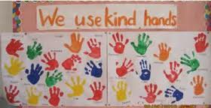
  - Use ‘kind hands’ in school
  - Look after school equipment
  - Walk through school safely

- Try my best at all times

          - Bring my home learning in on time
          - Work hard in all lessons
          - Use my neatest handwriting in all of my work

- Wear my uniform smartly with pride
  - Tuck my shirt in
  - Wear smart, black, school shoes
  - Wear correct PE Kit

Behaviour – Class Dojo

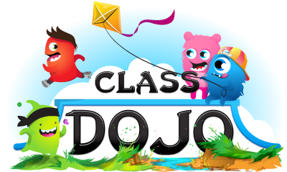
.
ClassDojo is a digital classroom management tool designed to help teachers improve behaviour and communicate more effectively with parents. Each pupil gets an avatar, which the child can personalise, and teachers use a tablet or computer to give green or red points throughout the school day.
Children can earn green dojos for working hard, helping others, choosing kind, giving good answers and many other positive behaviours. Red dojos are used to discourage behaviour which needs work, and provide a visual way for children to track their behaviour choices.
There are lots of features which will help you to see how well your child is doing in school:
- Class story – this is completely secure and can only be seen by connected parents. It’s a place to put photos and information about the children’s day so you can see how great they are in school.
- Messaging – class messaging is a still a feature so we can contact each other quickly and for free. It’s also a great way for children to show off their work with a photo.
The children love being able to show off what they’ve done in school, so please sign up as soon as possible using your code or the link sent to you.

