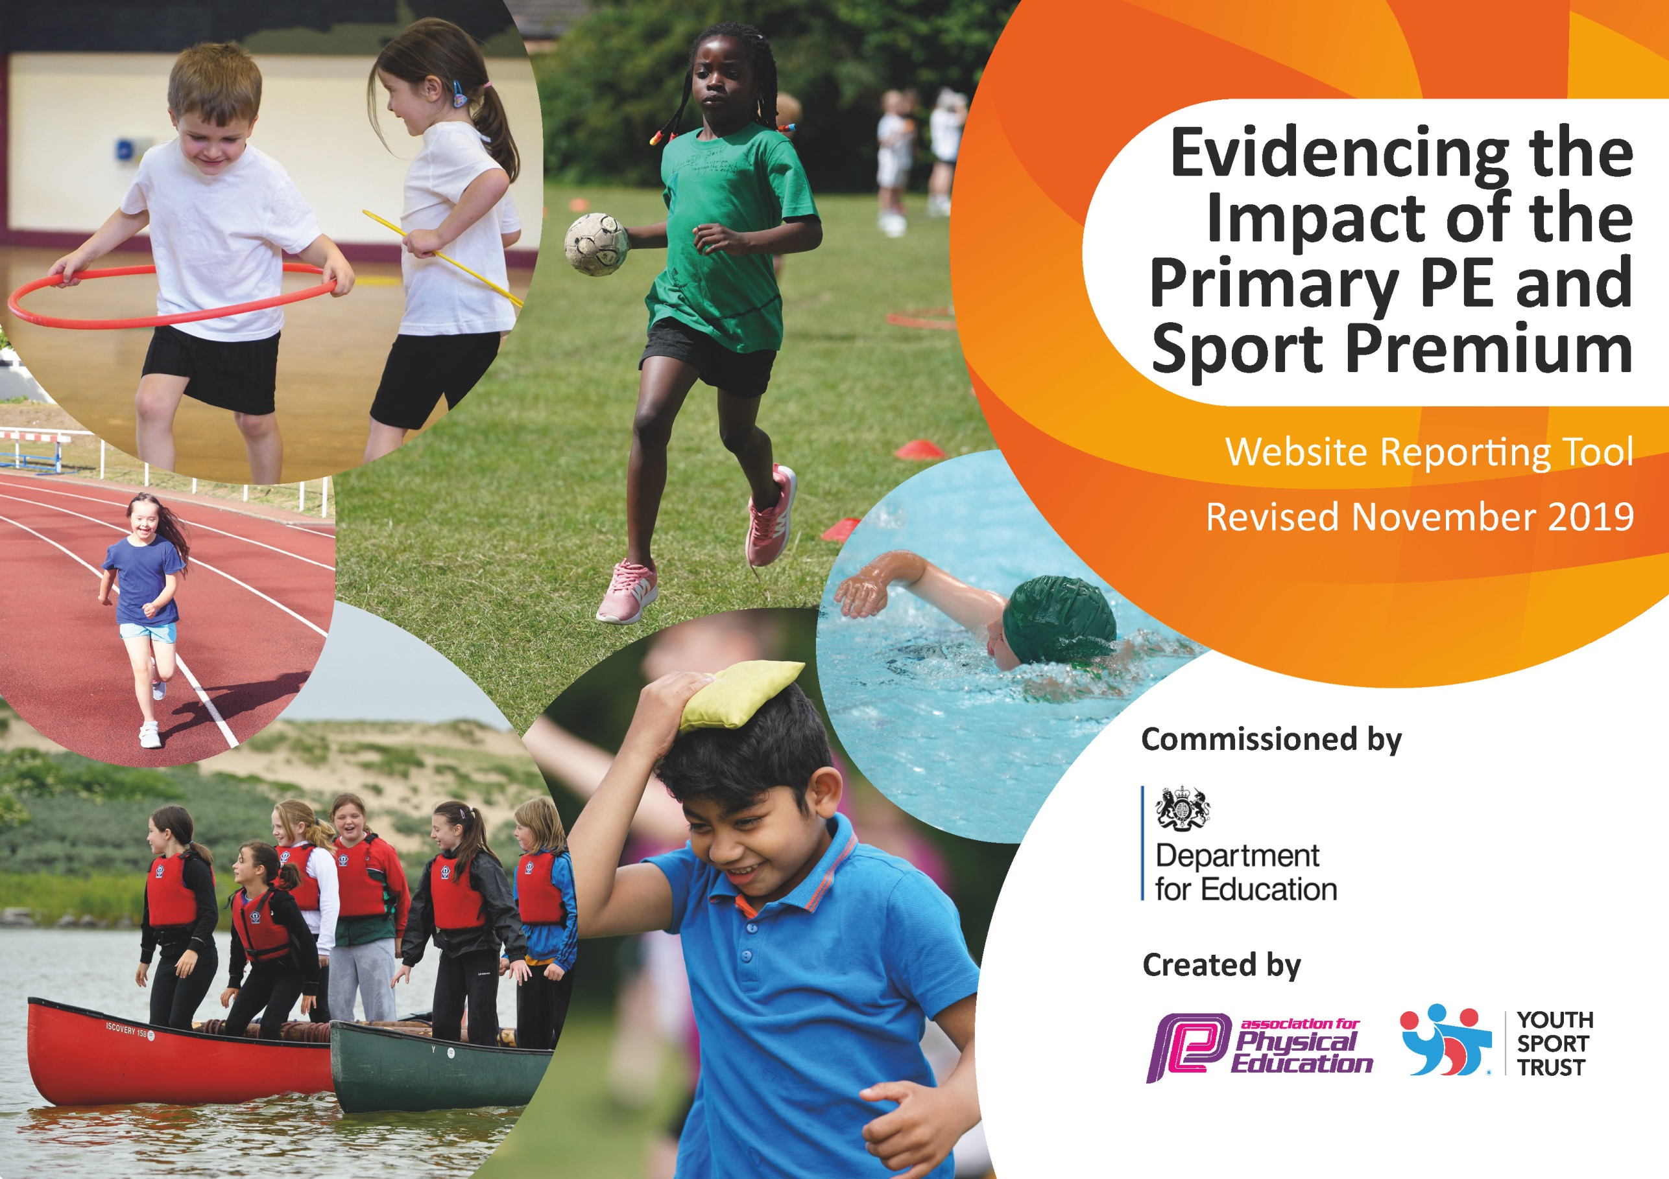
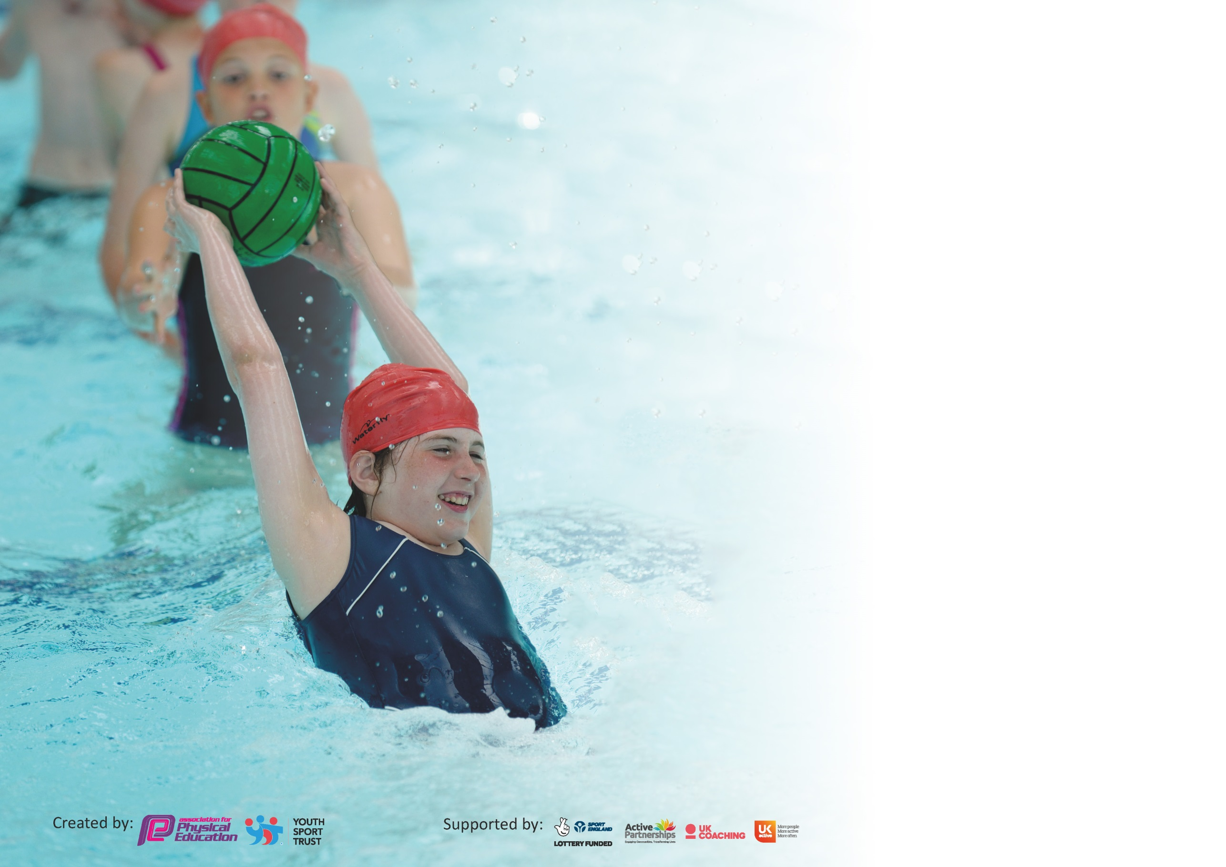

It is important that your grant is used effectively and based on school need. The Education Inspection Framework (Ofsted 2019 p64) makes clear there will be a focus on ‘whether leaders and those responsible for governors all understand their respective roles and perform these in a way that enhances the effectiveness of the school’.

Under the Quality of Education criteria (p41) inspectors consider the extent to which schools can articulate their curriculum (INTENT), construct their curriculum (IMPLEMENTATION) and demonstrate the outcomes which result (IMPACT).

To assist schools with common transferable language this template has been developed to utilise the same three headings which should make your plans easily transferable between working documents.

Schools must use the funding to make additional and sustainable improvements to the quality of Physical Education, School Sport and Physical Activity (PESSPA) they offer. This means that you should
use the Primary PE and Sport Premium to:

- Develop or add to the PESSPA activities that your school already offer
- Build capacity and capability within the school to ensure that improvements made now will benefit pupils joining the school in future years

Please visit gov.uk for the revised DfE guidance including the 5 key indicators across which schools should demonstrate an improvement. This document will help you to review your provision and to report your spend. DfE encourages schools to use this template as an effective way of meeting the reporting requirements of the Primary PE and Sport Premium.

We recommend you start by reflecting on the impact of current provision and reviewing the previous spend.

Schools are required to publish details of how they spend this funding as well as on the impact it has on pupils’ PE and sport participation and attainment by the end of the summer term or by 31st July 2020 at the latest.

We recommend regularly updating the table and publishing it on your website throughout the year. This evidences your ongoing self-evaluation of how you are using the funding to secure maximum, sustainable impact. Final copy must be posted on your website by the end of the academic year and no later than the 31st July 2020. To see an example of how to complete the table please click HERE.

Support for review and reflection - considering the 5 key indicators from DfE, what development needs are a priority for your setting and your pupils now and why? Use the space below to reflect on previous spend and key achievements and areas for development.

Key achievements to date until July 2021: | Areas for further improvement and baseline evidence of need:
- Swimming lessons for every child in Key Stage 2  - After school sports clubs  - Outdoor and adventurous activities for Years 4 and 6  - Participation in inter-schools sporting activities and competitions | - CPD for staff (gymnastics)  - Increase participation in after school clubs  - Development of intra-school sporting activities and competitions

Meeting national curriculum requirements for swimming and water safety.
What percentage of your current Year 6 cohort swim competently, confidently and proficiently over a distance of at least 25 metres?  N.B. Even though your pupils may swim in another year please report on their attainment on leaving  primary school at the end of the summer term 2020. | %
What percentage of your current Year 6 cohort use a range of strokes effectively [for example, front crawl, backstroke and breaststroke]? | %
What percentage of your current Year 6 cohort perform safe self-rescue in different water-based situations? | %
Schools can choose to use the Primary PE and Sport Premium to provide additional provision for swimming but this must be for activity over and above the national curriculum requirements. Have you used it in this way? | Yes

Action Plan and Budget Tracking
Capture your intended annual spend against the 5 key indicators. Clarify the success criteria and evidence of impact that you intend to measure to evaluate for pupils today and for the future.

Academic Year: 2021/2022 | Total fund allocated: £17,770 | Date Updated: 10/11/2021
Key indicator 1: The engagement of all pupils in regular physical activity – Chief Medical Officer guidelines recommend that primary school pupils undertake at least 30 minutes of physical activity a day in school |  |  |  | Percentage of total allocation:
 |  |  |  | %
Intent | Implementation |  | Impact | 30%
Your school focus should be clear what you want the pupils to know and be able to do and about  what they need to learn and to  consolidate through practice: | Make sure your actions to achieve are linked to your intentions: | Funding allocated: | Evidence of impact: what do pupils now know and what can they now do? What has changed?: | Sustainability and suggested next steps:
To provide swimming lessons for all children in Years 4, 5 and 6. | Swimming will take place once a week in the Autumn Term for Year 6 pupils. Additional swimming lessons will be provided for Year 6 pupils who have not met the standard.  By offering swimming lesson from Year 4, skills can be built over time so that by the end of Year 6, pupils have met the expected 25m standard. | £2,000 forecast
RNLI or Sue’s Swim School | Presentations to pupils in Key Stage 2 to teach water safety and rescue work - SAFE | FREE
Coach travel for swimming lessons | Transport to Bloxwich Leisure Centre each week is by coach | £2000 forecast
Introduce class yoga sessions as part of curriculum and after school clubs | Midlands Yoga to teach for 1 half term yoga to years 1-6 during spring term.  Year 1 and 2 – 30 mins each  Years 3-6 - 45 mins each | £1435
Key indicator 2: The profile of PESSPA being raised across the school as a tool for whole school improvement |  |  |  | Percentage of total allocation:
 |  |  |  | %
Intent | Implementation |  | Impact | 17%
Your school focus should be clear what you want the pupils to know and be able to do and about  what they need to learn and to  consolidate through practice: | Make sure your actions to achieve are linked to your intentions: | Funding allocated: | Evidence of impact: what do pupils now know and what can they now do? What has changed?: | Sustainability and suggested next steps:
To purchase new equipment to support teaching and learning in PE | Replace old sports equipment so that it is fit for purpose  Purchase equipment to enrich the curriculum for sport and PE including curriculum time and after-school clubs | £2460 forecast
Develop the playground, including resurfacing and markings for a range of sports and activities | Ensure that field and playground are marked to include the range of sports taught | £500 forecast

Key indicator 3: Increased confidence, knowledge and skills of all staff in teaching PE and sport |  |  |  | Percentage of total allocation:
 |  |  |  | %
Intent | Implementation |  | Impact | 6%
Your school focus should be clear  what you want the pupils to know  and be able to do and about  what they need to learn and to  consolidate through practice: | Make sure your actions to  achieve are linked to your  intentions: | Funding  allocated: | Evidence of impact: what do  pupils now know and what  can they now do? What has  changed?: | Sustainability and suggested  next steps:
Improve teaching of gymnastics | CPD for staff to improve teaching of gymnastics | £1000 forecast
Key indicator 4: Broader experience of a range of sports and activities offered to all pupils |  |  |  | Percentage of total allocation:
 |  |  |  | %
Intent | Implementation |  | Impact | 40%
Your school focus should be clear  what you want the pupils to know  and be able to do and about  what they need to learn and to  consolidate through practice: | Make sure your actions to  achieve are linked to your  intentions: | Funding  allocated: | Evidence of impact: what do  pupils now know and what  can they now do? What has  changed?: | Sustainability and suggested  next steps:
To provide a wide range of extra-curricular opportunities for sport and PE | We will be offering fun new clubs and introducing new sports, dance and other activities to encourage more pupils to take up sport and physical activities.  We will enter and run more sports competitions and take part in local competitions. | £1500 forecast
Subsidise Year 6 residential (outdoor and adventurous activity) so that all pupils are able to participate | To make sure the children of year 6 are experiencing something new. To encourage pupils to take on leadership or volunteer roles that support sport and physical activity outside of school. They will be trying new sports and activities that are not available within our local area. In addition, it will offer a broader experience of a range of sports and activities offered to those pupils. Secondary ready If possible, we will offer places to our Y5 children as a reward for good behaviour and hard work throughout the year. | £4500 forecast
Promote cycling and road safety | Provision of Bikeability for pupils in Years 5 and 6 (Level 1 and 2)  To ensure that pupils gain the skill of riding a bike, whilst ensuring their road safety. Promoting an alternative method of getting to school | £150 forecast
Take part in school sport enrichment activities. | Provide half termly enrichment activities related to sports to improve behaviour in school | £1000 forecast
Key indicator 5: Increased participation in competitive sport |  |  |  | Percentage of total allocation:
 |  |  |  | %
Intent | Implementation |  | Impact | n/a
Your school focus should be clear  what you want the pupils to know  and be able to do and about  what they need to learn and to  consolidate through practice: | Make sure your actions to  achieve are linked to your  intentions: | Funding  allocated: | Evidence of impact: what do  pupils now know and what  can they now do? What has  changed?: | Sustainability and suggested  next steps:
Achieve the School Games Mark | https://www.yourschoolgames.com/how-it-works/school-games-mark/ | Free

Signed off by
Head Teacher:
Date:
Subject Leader: | Stacey Westwood
Date: | 10/11/2021
Governor:
Date:

