Jubilee Academy Mossley

Quality First Teaching, Access and Inclusion: A Tiered Approach
2021-2022

Contents

- EEF Guide to supporting school planning TEMPLATE – TIERED MODEL
- Strategic overview
- Our approach to Pupil Absence and Local/National Lockdown
- Coronavirus related absences quick reference guide

Our approach to Pupil Absence and Local/National Lockdown
Short Absence  (Symptoms – Negative Result) |  | Longer Absence  (Positive Result/Quarantine for travel/track and tracing etc.) |  | Bubble closure/Local Lockdown/Tier 4
- Paper-based learning materials across the curriculum for the equivalent of a full timetable to be distributed using the academy’s known method e.g. online learning platform, email, post, collection, hand-delivery  - Frequency of KIT phone calls from academy staff (class teacher wherever possible) re: safeguarding, well-being, academic progress to correlate with minimum frequency detailed below, but will be more often wherever possible.  - All completed work to be returned to the academy  - On swift return following negative test result  - Via drop-off, post or collection in the event of a longer absence (quarantined)  - In the event of a positive test result of a pupil, whilst the above provision would remain, completion of the above would not be expected whilst the child is unwell  - In the event of a positive result of a family-member which results in quarantine but the child is well, academies will prepare immediately for longer absence |  | - Learning materials (paper-based and/or online depending on the academy’s most effective approach and the context and accessibility of the child(ren) concerned) to be distributed/shared to cover the full curriculum for the equivalent of a full timetable for the period of absence  - Wherever possible, child(ren) to be provided with a device to access learning/resources remotely  - Content of the learning materials to ensure progression through the curriculum aligned with  - Teacher’s planned curriculum content  - Age/stage appropriate, progressive curriculum content from alternative Dfe recommended source e.g. Oak National Academy  Frequency of KIT phone calls from academy staff (class teacher wherever possible) re: safeguarding, well-being, academic progress to correlate with minimum frequency detailed below, but will be more often wherever possible. |  | - Provision for key worker and critical worker pupils to mirror the progressive, curriculum detailed below but delivered within the academy  - Learning materials (paper-based and/or online depending on the academy’s most effective approach and the context and accessibility of the child(ren) concerned) to be distributed/shared to cover the full curriculum for the equivalent of a full timetable for the period of absence  - Wherever possible, child(ren) to be provided with a device to access learning/resources remotely  - Content of the learning materials to ensure progression through the curriculum aligned with  - Teacher’s planned curriculum content  - Age/stage appropriate, progressive curriculum content from alternative Dfe recommended source e.g. Oak National Academy  - Use of pre-recorded and/or live lessons  - Frequency of KIT phone calls from academy staff (class teacher wherever possible) re: safeguarding, well-being, academic progress to correlate with minimum frequency detailed below, but will be more often wherever possible.  - Socially distant home visits to take place where vulnerability RAG rating determines these necessary.  - Teachers continue to plan for the delivery and assessment of a progressive curriculum using the guidance above
Minimum Frequency for KIT Phone Calls
EHCP, CP | CIN |  | Early Help, wider vulnerable |  | All other
Daily | Every 2 days |  | Every 3 days |  | Weekly

Remote Education
Remote Education Lead: Kate Benton
We use a combination of the following approaches to teach pupils remotely:
  - live and/or recorded teaching delivered by academy staff
  - high-quality curriculum resources or videos such as commercially available websites supporting the teaching of specific subjects or areas, including video clips or sequences
  - printed paper packs including supportive prompts and scaffolds produced by teachers (e.g. workbooks, worksheets)
  - textbooks and reading books pupils have at home
  - long-term project work and/or internet research activities
We recognise that some pupils, for example some pupils with special educational needs and disabilities (SEND), may not be able to access remote education without support from adults at home. We acknowledge the difficulties this may place on families, and we will work with parents and carers to support those pupils in the following ways:
- Personalised learning packs
- Support from the class staff team
- SEND leader support
- Resources from school
- Outside agency support
- KIT calls
Study Time
Each academy will share a timetable.
We expect that remote education (including remote teaching and independent work) will take pupils broadly the following number of hours each day:
EYFS | Key Stage 1 | Key Stage 2
Up to 3 hours | 3 hours | 4 hours
- Wherever possible, pupils should follow the structure of the academy’s suggested timetable which will accompany the remote education resources
- Pupils must take regular breaks between periods of study as they would when attending the academy in person

Online Remote Education
Wherever possible, pupils will be provided with a device to access learning/resources remotely. Please find our learning platforms below:
Class Dojo https://classdojo.com/
Microsoft Teams https://www.microsoft.com/en-gb/microsoft-teams/log-in
Times table rockstars https://ttrockstars.com/
Lexia https://www.lexialearning.com/remote-learning/families/core5/log-in
Lingotots https://www.lingotot.co.uk/JubileeAcademy.html
Yoga https://us02web.zoom.us/rec/share/etjQJSyr_rsxy_snHf3wC88G9gc02NqwontVK-8FR8_eIIUrcG73dIQwkAyLE1zG.U75iwXpk4CXMBWhc

Paper-based Remote Education
Learning materials will be shared to cover the full curriculum for the equivalent of a full timetable for the period of absence. Distribution and return of these resources will be in accordance with the local and national restriction/tier guidance at that time. This process will be communicated clearly by staff each time.
Engagement and Feedback
We use a combination of the following approaches to monitor engagement, gauge pupils’ progress and provide regular feedback:
- Phone calls at least weekly
- Whole class feedback given during live sessions on Class Story or at the end of the week
- Individual feedback during KIT calls
- Feedback to work submitted on Class Dojo –all work will be acknowledged by approving and ‘liking’.
- Feedback will be provided in the comments box where appropriate –this can be responded to and followed up by children.
- Children submitting work will receive written feedback at least once per week.
- Where pupils are not able to share their learning via Class Dojo, completed work may be returned on a Friday when learning pack for the following week is collected.

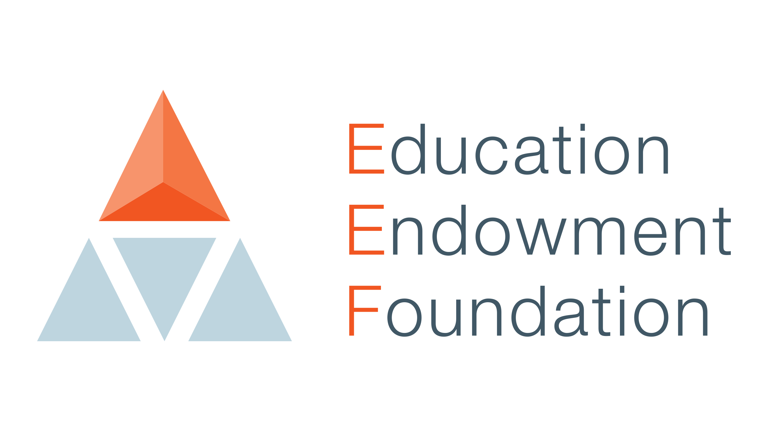
Jubilee Academy Mossley

EEF GUIDE TO SUPPORTING SCHOOL PLANNING (2020-21) – TIERED MODEL

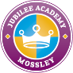
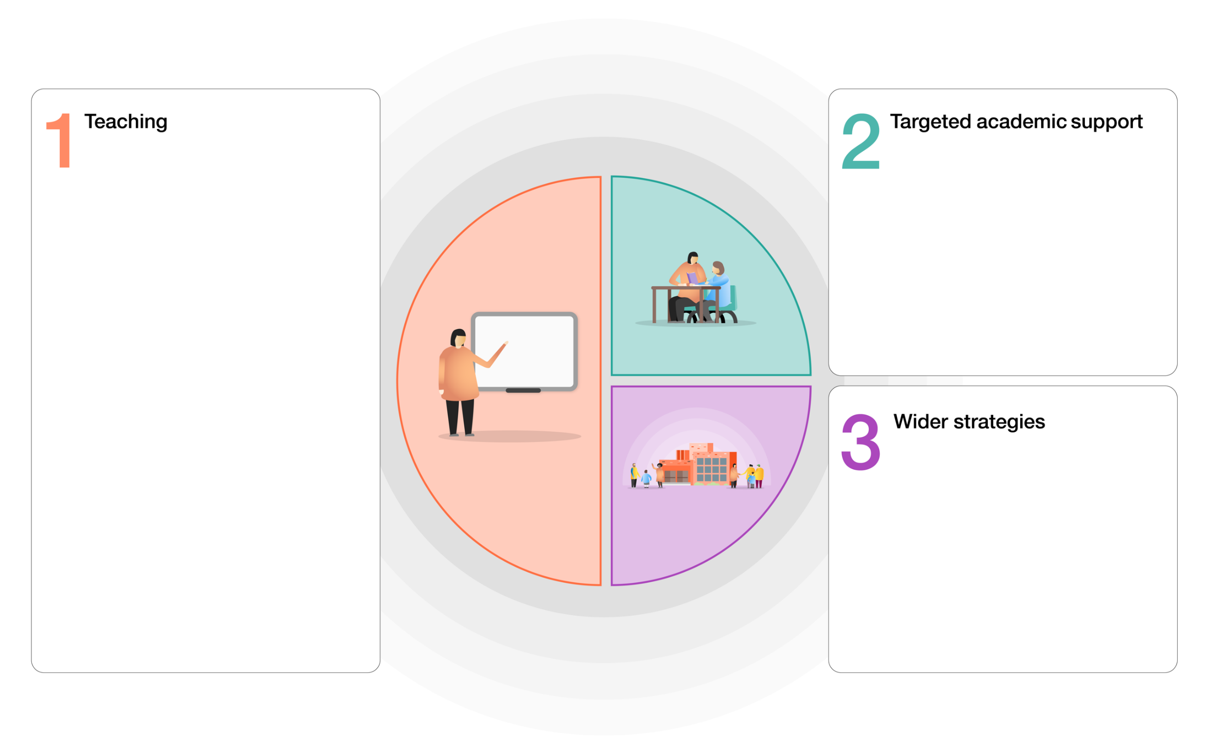
- Quality First Teaching supported by evidence based CPD for teachers and support staff.
- A peer-support model to help embed and sustain research-based teaching strategies.
- A broad and engaging curriculum that focuses on building on skills acquisition
- Whole-class reading approach underpinned by clearly defined formative assessment practices.
- Curriculum ‘essentials’ for Reading, Writing and Maths are identified and taught / revisited across wider curriculum subjects.
- Development of a Maths Mastery approach supported by White Rose
- Daily breakfast club in bubbles.
- Extensive outdoor learning provision.
- A rich PHSE programme
- Targeted mental health identification and support

- Same-day in-class intervention.
- Teacher-led targeted group teaching for Year 5 and Year 6 pupils.
- Specific intervention programmes led by both Teachers and Teaching Assistants.
- Baseline assessments to ensure gaps are closed through targeted QFT, skills and knowledge.
Primary
Diagnostic Assessment Overview
September 2021
Year Group |  | What? | When? |  | How? |  | Aims
NUR |  | Existing arrangements  EYFS mid term review | Existing arrangements detailed in Assessment Cycle |  | Existing arrangements |  | - Diagnostic assessments used to inform planning and additional support.
REC |  | Existing arrangements  EYFS mid term review | Existing arrangements detailed in Assessment Cycle |  | Existing arrangements |  | - Diagnostic assessments used to inform planning and additional support.
Y1 |  | GLD criteria | October 2021 |  | Using your existing diagnostic assessment materials |  | - Diagnostic assessments used to inform planning and additional support.  - Pupils who were expected to achieve GLD to have met this standard by the end of Autumn 1.
 |  | Phonics Screening Check | November 2021  March 2022  June 2022 |  |  |  | - Diagnostic assessments used to inform planning and additional support.
Y2 |  | Phonics Screening Check  NTS Assessments  Statutory Assessments | December 2021  Termly  March 2022  May 2022 |  |  |  | - Diagnostic assessments used to inform planning and additional support.  - Pupils who were expected to pass Phonics Screening Check to have met this standard by the end of Autumn 1.
Y3 |  | NTS Assessments  Multiplication check | Termly  January 2022 and July 2022 |  |  |  | - Diagnostic assessments used to inform planning and additional support.  - Pupils who were expected to achieve EXS+ to have met this standard by the end of Autumn 1.
Y4 |  | NTS Assessments  Multiplication check | Termly  January 2022 and June 2022 |  |  |  | - Diagnostic assessments used to inform planning and additional support.  - Pupils who were expected to achieve EXS+ to have met this standard by the end of Autumn 1.
Y5 |  | NTS Assessments | Termly |  |  |  | - Diagnostic assessments used to inform planning and additional support.  - Pupils who were expected to be operating at ‘age related’ to have met this standard by the end of Autumn 1.
Y6 |  | NTS assessments  Writing TA | November 2021  March 2022  May 2022 |  |  |  | - Diagnostic assessments used to inform planning and additional support.  - Pupils who were expected to be operating at ‘age related’ to have met this standard by the end of Autumn 1.
Strategic Overview
This is the overview of how we are addressing the gaps in learning caused during school closures.
Year group | English |  |  | Maths |  | JAM |  | Home learning-Using both Class Dojo and Microsoft Teams online platform, which can swiftly become Blended learning in the event of local lockdown
Nursery | - Nursery children who have remained will continue with Phase 1 – Letters and Sounds phonics in small group, adult led sessions – based on start of year assessments (baseline |  |  | Children who have remained in Nursery will participate in small group maths sessions in line with their start of year assessment (baseline).  Maths Mastery Curriculum to be used as a guide line with a focus on Number. |  | Following Development matters and themes |  | Use Class Dojo online communication platform to facilitate:  *Letters and sounds/ RWI nursery-phonics  *Number bonds using TT Rock Stars/ Ten town/ number blocks  *Top marks: Number games  *Teach your Monster to Read – The Usborne Foundation /Reading eggs/ oxford owl  *phonics play  Use of Microsoft teams to facilitate:  *Letters and sounds/ RWI nursery session  *Story time  *School assembly twice a week  Use of school packs for parents who can-not access online portals
Reception | - Baseline assessment of Phonics to be carried out to ascertain individual starting points.  - Children will continue with RWI  - Colourful semantics |  |  | Mathematics Mastery Curriculum – White Rose . Children will follow the planned units with a focus on number for much of the autumn term. |  | Following Development matters and themes |  | Use Class Dojo online learning platform to facilitate:  *Cosmic Kids  *RWI-phonics  *Number bonds using TT Rock Stars  *White Rose Maths  Use of Microsoft teams to facilitate:  *RWI session  *Story time  *School assembly twice a week  Use of school packs for parents who can-not access online portals
Years 1  to 4 | - Extra time on timetable created to focus on key skills and objectives – Punctuation, vocabulary and spelling are key priorities.  - Years 1 and 2 to daily systematic phonics sessions a day to catch up and ensure children are working at the expected phonics phases before moving on to new sounds/phases.  - Any year 3 children who did not pass phonics screening test in Year 1/2 to have additional phonics interview with a TA  - Colourful semantics  - Word aware  - QLA analysis used termly to generate bespoke intervention through NTS |  |  | White Rose with new updated curriculum to catch up and move onto new learning.  Online content available for children to embed their learning at home via Class Dojo learning platform.  Mathletics  QLA analysis used termly to generate bespoke intervention through NTS |  | Morning activities of  Reading  Maths to be timetabled in |  | Use Class Dojo online learning platform to facilitate:  *Learning suggested timetable  *Cosmic kids/ Yoga sessions recorded  *BBC bitesize  *Times Table Rock Stars  *Number bonds using TT Rock Stars  *White Rose home learning  * Lingotots home learning lessons recorded  *Top marks  *Home learning map (cross curricular)  *phonics play  *Pie Corbett workbooks  *Lexia (1/2)  *QLA analysis used termly to generate bespoke intervention through NTS  *Music sessions recorded  Use of Microsoft Teams to facilitate:  *RWI session  *Introduction to the lessons recorded  *Story time  *School assembly twice a week  Use of school packs for parents who can-not access online portals
Years 5 and 6 | - Extra time on timetable created to focus on key skills and objectives -  - Writing- Punctuation, vocabulary and spelling are key priorities.  - Word aware  - Colourful semantics  - QLA analysis used termly to generate bespoke intervention through NTS |  |  | White Rose with new updated curriculum to catch up and move onto new learning.  NRICH and NCETM to be used alongside White Rose curriculum.  Ready to progress DFE/ NCETM  QLA analysis used termly to generate bespoke intervention through NTS |  | Morning activities of  Reading  Maths to be timetabled in |  | Use Class Dojo online learning platform to facilitate:  *Learning suggested timetable  *Cosmic kids  *BBC bitesize  *My mini maths  *Times Table Rock Stars  *White Rose home learning  * Home learning map (cross curricular)  *Maths Whizz  * Lingotots home learning lessons recorded  *QLA analysis used termly to generate bespoke intervention through NTS  * Music sessions recorded  Use of Microsoft Teams to facilitate:  *Introduction to the lessons recorded  *Story time  *School assembly twice a week  Use of school packs for parents who can-not access online portals
SEN Pupils | - Pupils will be re-assessed for intervention.  - Interventions to start as soon as children are back at school.  - Small phonics groups to be implemented for SEN and LA pupils.  - Individualised support from SENCO and pastoral support  - QLA analysis used termly to generate bespoke intervention through NTS |  |  | SENCO to have Speech and language plans ready with resources to give parents to facilitate intervention at home.  SENCO to loan physical equipment to parents where needed.  QLA analysis used termly to generate bespoke intervention through NTS |  | Prime area of need is social emotional / speech and language so resources available for these children.  Multi agency support with families to be facilitated in and out of school. |  | Use Class Dojo online learning platform to facilitate:  *Learning suggested timetable  *Lexia  *Cosmic kids  *BBC bitesize  *My mini maths  *Times Table Rock Stars  *White Rose home learning  * Home learning map (cross curricular)  *Maths Whizz  *QLA analysis used termly to generate bespoke intervention through NTS  *RWI phonics  Use of Microsoft Teams to facilitate:  *Introduction to the lessons recorded  *Story time  *School assembly twice a week  Use of school packs for parents who can-not access online portals

Coronavirus related absences quick reference guide – September 2021
What to do if… | Action needed | Code | Return to school when…
…my child has coronavirus symptoms | Do not come to school  - Contact school daily  - Self-isolate  - Get a test  - Inform school immediately about test result | Code X | …the test comes back negative.
…my child tests positive for coronavirus | - Do not come to school  - Contact school daily  - Self-isolate for at least 7 days  - Inform school immediately about test result | Code I | ...they feel better. They can return to school after 7 days if they have 2 negative LFTs on day 6 and 7. If either of these are positive isolate for 10 days.
…somebody in my household has coronavirus symptoms | - Child to attend school  - LFT daily for 7 days | Code / | …continue attending unless child develops symptoms or positive LFT.
…somebody in my household has tested positive for coronavirus | - Child to attend school  - LFT daily for 7 days | Code / | …continue attending unless child develops symptoms or positive LFT.
… NHS test and trace have identified my child as a ‘close contact’ of somebody with symptoms or confirmed coronavirus | - Child to attend school  - LFT daily for 7 days  - Only isolate if advised to by NHS | Code / | …continue attending unless child develops symptoms or positive LFT.
…we/my child travelled and has to self-isolate a part of a period of quarantine | - Do not take unauthorised leave in term time  - Consider quarantine requirements and FCO advice when booking travel  - Provide information to school as per attendance policy  Returning from a destination where quarantine is needed:  - Do not come to school  - Contact school daily  - Self-isolate for required period | Code X | …the quarantine period has been completed
…we have received medical advice that my child must resume shielding. | - Do not come to school  - Contact school as required by the pastoral team  - Shield until you are informed that restrictions are lifted and shielding is paused again | Code X | …school inform you that restrictions have been lifted and your child can return to school again.

Parent / Carer calls saying their child has come into contact with somebody who has Covid symptoms and must self-isolate. (Ask if child is well? If the answer is “yes” follow the flowchart below.

Do you have access to the internet through a phone / tablet or laptop?

No
Yes

Paper based learning
While your child is at home it is compulsory for them to complete home learning activities that the teacher has set if they are well enough to.
Before we carry on can we just ensure that we have your correct address details.
We can get a home learning pack printed out and sent to your address this will contain all the children’s core subject learning.

Online Learning
While your child is at home it is compulsory for them to complete home learning activities that the teacher has set if they are well enough to.
Your child’s year group further information about home learning on Class Dojo.
- Are you signed up on Class Dojo?
- I will let the class teacher know that a home learning pack needs to be sent and any further details about live sessions.
- If you can not access please let us know if a paper copy needs to be supplied.

