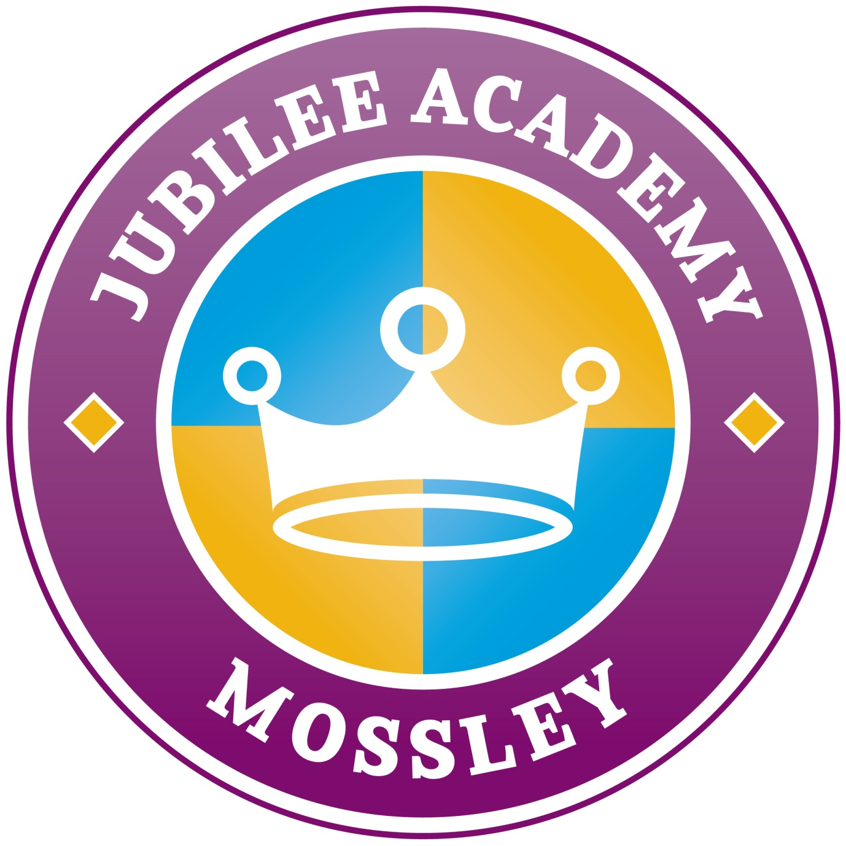

Induction Information
Pack

Welcome to Jubilee Academy!

Jubilee Academy is ‘Good’!

Life at Jubilee Academy is fun, enjoyable and enriching and we are very, very proud of each of our children. We continue to work hard to inspire every child in our school to succeed and develop. We pride ourselves on our varied, enriched curriculum and the confidence and achievements of our pupils.

We want the children who attend Jubilee Academy Mossley to leave us in Year 6 with the skills and positive thinking needed to achieve their ambitions and to lead happy, successful lives. We offer an exciting, hands-on learning experience that is tailored to the needs of all our children. You will often find them using a broad range of devices including iPads and laptops, taking part in Commando Joe lessons, making music in the Rock It Project and having their say about school through our School Council.

Our school times are as below:
Class | Start School | Lunch Time | Finish School
Morning Nursery | 8.45am | N/A | 11.45am
Afternoon Nursery | 12.30pm | N/A | 3.30pm
Jungle | 8.45am | 11.55am-12.55pm | 3.10pm
Y1 and Y2 | 8.45am | 12.00pm-12.55pm | 3.10pm
Y3, Y4, Y5 and Y6 | 8.45am | 12.05pm-12.55pm | 3.15pm

Vision Statement

Together we will succeed

We believe that every child is important and deserves a first class education. We believe everyone has hidden potential to be uncovered and nurtured. We aim to inspire every child in our school to succeed and seek to provide them with the opportunities to develop to their full potential. We pride ourselves on our varied, enriched curriculum and the confidence and achievements of our pupils. We want the children who attend Jubilee Academy Mossley to leave us with the skills and positive thinking needed to achieve their ambitions and to lead happy and successful lives. To achieve this vision we:

TEACHING & LEARNING
- Have high academic expectations
- Encourage children to become independent learners
- Provide a varied and enriched curriculum
- Enhance our children’s learning experiences through a wide range of exciting, challenging and extra-curricular activities

SOCIAL
- Recognise individual and school success and focus on the positive
- Have respect for each other and resources
- Foster an atmosphere of honesty and trust
- Show happiness, stability and continuity
- Communicate effectively with all stakeholders of the school
- Strive for high self–esteem in all of our children
- Encourage involvement in all aspects of school life
- Build team-spirit through sports, music, arts and extra-curricular activities

SCHOOL ENVIRONMENT
- Maintain a secure environment
- Provide a happy and stable environment
- Provide a stimulating and effective environment
- Create a caring environment
- Promote a healthy life-style

COMMUNITY
- Are actively involved in the community
- See parents as partners in their child’s education
Jubilee Academy Mossley’s Family Rules

As part of the Jubilee Academy family, I promise to:
- Treat others with respect
  - Listen carefully when someone is talking to you
  - Say ‘please’ and ‘thank you’
  - Work with other children as part of a team
  - Use school-appropriate language (use kind words)
  - Tell the truth

- Keep my hands, feet and objects to myself
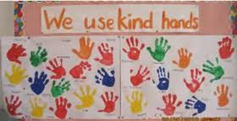
  - Use ‘kind hands’ in school
  - Look after school equipment
  - Walk through school safely

- Try my best at all times
          - Bring my home learning in on time
          - Work hard in all lessons
          - Use my neatest handwriting in all of my work

- Wear my uniform smartly with pride
  - Wear my tie correctly
  - Tuck my shirt in
  - Wear smart, black, school shoes

Uniform

A purple knitted v-neck school jumper/cardigan with the academy logo on. These are available to purchase from Clemmy’s in Darlaston located in the row of shops next to Asda or Crested School Wear in the Victorian Arcade in Walsall.
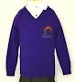
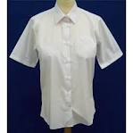
Nursery and Reception – A white polo shirt
Y1-Y6 - A white shirt with a collar. Please note this must be a shirt and
not a polo shirt.
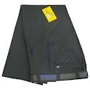
A charcoal grey pair of trousers or skirt. This is the very dark grey.

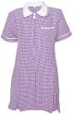
Girls may wear a purple checked summer dress during warmer weather. These are available from Asda and Sainsburys.

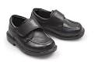
Black school shoes - NO trainers, Ugg boots, high heeled shoes/boots or sandals. If children come to school in trainers they will have to put their PE pumps on.
o be ordered.
PE Kit – All full time children (Reception to Y6) MUST have a PE Kit in school at all times. This should consist of a team coloured t-shirt, black shorts and pumps.

Behaviour – Class Dojo

.
ClassDojo is a digital classroom management tool designed to help teachers improve behaviour and communicate more effectively with parents. Each pupil gets an avatar, which the child can personalise, and teachers use a tablet or computer to give green or red points throughout the school day.
Children can earn green dojos for working hard, helping others, choosing kind, giving good answers and many other positive behaviours. Red dojos are used to discourage behaviour which needs work, and provide a visual way for children to track their behaviour choices.
There are lots of features which will help you to see how well your child is doing in school:
- Class story – this is completely secure and can only be seen by connected parents. It’s a place to put photos and information about the children’s day so you can see how great they are in school.
- Messaging – class messaging is a still a feature so we can contact each other quickly and for free. It’s also a great way for children to show off their work with a photo.
The children love being able to show off what they’ve done in school, so please sign up as soon as possible using your code at: https://www.classdojo.com/

